Moldova
Chronology
c.803 - 9.. Bulgarian rule.
9.. - 10.. Pechenegs (Paçinaq) rule.
10.. - 1241 Cuman-Kipchak rule.
1241 - 13.. Mongol rule.
13.. Part of Principality of Moldavia (Țara Moldovei)
(see Romania).
1541 Moldavia part of the Ottoman Empire.
28 May 1812 Annexed by Russia; the term "Bessarabia"
(Bessarabiya) appears for the first time to
designate the former Eastern half of Moldavia
(Old Style date 16 May 1812).
11 May 1818 Establishment of the Bessarabian oblast
(Bessarabskaya oblast') - for the first time the
territory of Bessarabia is organized as a separate
political entity (Old Style date 29 Apr 1918)(with
local autonomy until 12 Mar 1828 [Old Style 29
Feb 1828]) under special By-laws [Ustav])
(subordinated to the Governorate-general of
Novorossiya and Bessarabia 12 May 1822-1874).
30 Mar 1856 Following the Crimean war, Russia is forced to cede
the South-western corner of Bugeac (Ismail,
Cahul and Bolgrad counties) back to the
Principality of Moldavia.
28 Oct 1873 Reorganized as the Bessarabian governorate
(Bessarabskaya guberniya).
13 Jul 1878 Counties of Ismail, Cahul and Bolgrad are returned
to Russia.
15 Dec 1917 Declaration of republic is passed by the National
Diet (as part of a Russian federative democratic
republic); Moldavian Democratic Republic
(Republica Democratică Moldovenească [Moldavskaya
Narodnaya Respublika])(Old Style date 2 Dec 1917).
14 Jan 1918 - 26 Jan 1918 Bolshevik Romanian Front Committee ("Rumcherod")
units take power in Kishinev (Old Style dates
1-13 Jan 1918)(see under Ukraine).
26 Jan 1918 Rumania occupies Kishinyov (Kishinev)(by 10 Mar 1918
all of Bessarabia)(Old Style 13 Jan 1918).
6 Feb 1918 Declaration of independence is passed by the
National Diet (Sfatul Țării)(Old Style date 24
Jan 1918).
9 Apr 1918 Incorporation into Rumania as Bessarabia (Basarabia)
(Old Style 27 Mar 1918), act of unification with
Romania as autonomy is passed by the National Diet
(autonomous until 10 Dec 1918 [Old Style date 27
Nov 1918]).
23 Apr 1918 Royal decree on unification of 22 Apr 1918 is
promulgated in Rumania (Old Style 10 Apr 1918).
5 May 1919 - 25 Aug 1919 Bessarabian Socialist Soviet Republic proclaimed in
exile at Odessa, claiming the former Bessarabian
governorate, as part of the Russian S.F.S.R., with
provisional exile headquarters at Tiraspol.
1 Jan 1920 Parliamentary act of unification is promulgated in
Rumania (passed by parliament on 29 Dec 1919,
and signed by the King on 31 Dec 1919).
20 Oct 1920 Rumanian annexation internationally recognized (but
not recognized by Russian S.F.S.R. or Soviet
Union).
11 Oct 1924 Moldavian A.S.S.R. established within the
Ukrainian S.S.R. by the Soviet Union.
28 Jun 1940 - 2 Aug 1940 Bessarabia occupied by Soviet Union.
2 Aug 1940 Annexed by the Soviet Union as Moldavian Soviet
Socialist Republic (Republica Sovietică Socialistă
Moldovenească/Moldavskaya Sovetskaya
Socialističeskaya Respublika)(see below).
2 Jul 1941 Rumanian invasion begins (Chisinau occupied 16 Jul
1941).
16 Jul 1941 - 31 Jul 1941 Bessarabia occupied by Rumania.
1 Aug 1941 - 24 Aug 1944 Incorporated into Rumania as the Bessarabia
governorate (Guvernământul Basarabiei).
24 Aug 1944 Re-incorporation into the Soviet Union
(recognized by Romania 15 Sep 1947).
1 Sep 1989 Moldovan/Romanian is made the state language, using
Latin script.
5 Jun 1990 Soviet Socialist Republic of Moldova (Republica
Sovietică Socialistă Moldova).
23 Jun 1990 Declaration of state sovereignty.
2 Sep 1990 Transnistria declares independence from Moldova
(not recognized).
23 May 1991 Republic of Moldova (Republica Moldova).
27 Aug 1991 Independence declared.
26 Dec 1991 Independence effective (dissolution of U.S.S.R.).
6 Mar 1994 Referendum rejects union with Romania by 97.9%.
16 Mar 2023 Romanian is named the official state language.
Calendar Note: Dates are given according to the New Style (Gregorian) calendar. Russia used the Old Style (Julian) calendar until 1 Feb/14 Feb 1918, as did Romania until 4 Mar/18 Mar 1920.
Moldavian Soviet Socialist Republic
Note: Russian names with Moldavian/Romanian in parentheses until 1 Sep 1989, then Moldavian/Romanian names with Russian in parentheses.
2 Aug 1940 Moldavian Soviet Socialist Republic (Republica Sovietică
Socialistă Moldovenească/Moldavskaya Sovetskaya
Socialističeskaya Respublika) is formed from the
Moldavian A.S.S.R. and (formerly Romanian) Bessarabia.
2 Aug 1940 Accession to the Soviet Union (see under Russia).
10 Feb 1941 Cyrillic introduced for the Moldavian language.
1 Sep 1989 Moldovan/Romanian is made the state language, using
Latin script.
5 Jun 1990 Soviet Socialist Republic of Moldova (Republica Sovietică
Socialistă Moldova).
16 Jul 1941 - 24 Aug 1944 Rumanian occupation and annexation.
1 Sep 1989 Moldovan/Romanian is made the state language.
23 May 1991 Republic of Moldova (Republica Moldova).
27 Aug 1991 Independence declared.
First Secretaries of the Central Committee of the Communist Party (Bolsheviks) of Moldavia
14 Aug 1940 - 27 Jan 1945 Pyotr Grigoryevich Borodin
(Piotr Borodin) (acting to 4 Sep 1940)
(in Russian S.F.S.R. exile 16 Jul 1941 - 24 Aug 1944)
(b. 1905 - d. 1986)
27 Jan 1945 - 20 Jul 1946 Nikita Leontyevich Salogor
(Nikita Salogor) (acting)
(b. 1901 - d. 1981)
20 Jul 1946 - 6 Jul 1950 Nikolay Grigoryevich Koval'
(Nicolae Covali) (b. 1904 - d. 1970)
6 Jul 1950 - 13 Oct 1952 Leonid Ilyich Brezhnev
(Leonid Brejnev) (b. 1906 - d. 1982)
First Secretaries of the Central Committee of the Communist Party of Moldavia
(from Jun 1990, Communist Party of Moldova)
 | 13 Oct 1952 - 25 Oct 1952 Leonid Ilyich Brezhnev (s.a.)
25 Oct 1952 - 6 Feb 1954 Dmitriy Spiridonovich Gladkiy
(Dimitrie Gladki) (b. 1911 - d. 1959)
6 Feb 1954 - 29 May 1961 Zinoviy Timofeyevich Serdyuk
(Zinovie Serdiuc) (b. 1903 - d. 1982)
29 May 1961 - 22 Dec 1980 Ivan Ivanovich Bodyul
(Ion Bodiul) (b. 1918 - d. 2013)
22 Dec 1980 - 16 Nov 1989 Semyon Kuz'mich Grossu
(Semion Grossu) (b. 1934)
16 Nov 1989 - 4 Feb 1991 Pyotr Kirillovich Luchinskiy
(Petru Lucinschi) (b. 1940)
4 Feb 1991 - 23 Aug 1991 Grigore Isidorovici Eremei
(Grigoriy Isidorovich Yeremey)
("leading role" of the party abolished 10 May 1990)
(b. 1935)
Chairman of the Bessarabian Provisional Revolutionary Committee
2 Aug 1940 - 10 Feb 1941 Sergey Danilovich Burlachenko
(Serghei Burlacenco) Aug 1940 PCM
(b. 1899 - d. 1962) KPU-B;
Chairmen of the Presidium of the Supreme Soviet
10 Feb 1941 - 28 Mar 1951 Fyodor Grigoryevich Brovko
(Fedor Brovko)
(in Russian S.F.S.R. exile 16 Jul 1941 - 24 Aug 1944)
(b. 1904 - d. 1960) PCM-B
28 Mar 1951 - 3 Apr 1963 Ivan Sergeyevich Koditsa
(Ion Codiţă) PCM
(b. 1899 - d. 1980) PCM-B;1952
3 Apr 1963 - 10 Apr 1980 Kirill Fyodorovich Ilyashenko
(Chiril Iliaşenko)
(b. 1915 - d. 1980) PCM
10 Apr 1980 - 24 Dec 1985 Ivan Petrovich Kalin
(Ivan Călin) (b. 1935 - d. 2012) PCM
 | 24 Dec 1985 - 12 Jul 1989 Aleksandr Aleksandrovich Mokanu (Alexandru Mocanu) (b. 1934 - d. 2018) PCM
12 Jul 1989 - 29 Jul 1989 Ivan Konstantinovich Chyoban
(Ion Ciobanu) (acting) (b. 1927 - d. 2001) PCM
29 Jul 1989 - 27 Apr 1990 Mircha Ivanovich Snegur
(Mircea Ion Snegur) (b. 1940 - d. 2023) PCM
Chairman of the Supreme Soviet
 | 27 Apr 1990 - 3 Sep 1990 Mircea Ion Snegur PCM;Jun 1990 (s.a.) Non-party
President
3 Sep 1990 - 27 Aug 1991 Mircea Ion Snegur
(s.a.) Non-party
Chairmen of the Council of People's Commissars
 | Главы правительства Молдавии
10 Feb 1941 - 19 Apr 1945 Tikhon Antonovich Konstantinov
(Tihon Constantinov) (in Russian S.F.S.R. exile 16 Jul 1941 - 24 Aug 1944)
(b. 1898 - d. 1957) PCM-B
19 Apr 1945 - 4 Apr 1946 Nikolay Grigoryevich Koval'
(Nicolae Covali) (s.a.) PCM-B
 | Chairmen of the Council of Ministers
 | 4 Apr 1946 - 19 Jul 1946 Nikolay Grigoryevich Koval' (s.a.) PCM-B
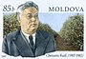 | 19 Jul 1946 - 23 Jan 1958 Gerasim Yakovlevich Rud'  (Gherasim Rudi) PCM  (b. 1907 - d. 1982) PCM-B;1952
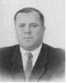 | 23 Jan 1958 - 24 Apr 1970 Aleksandr Filippovich Diorditsa  (Alexandru Diordiţă) (b. 1911 - d. 1996) PCM
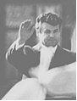 | 24 Apr 1970 - 1 Sep 1976 Pyotr Andreyevich Paskar  (Petru Pascari)1st time)(b. 1929) PCM
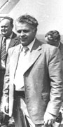 | 1 Sep 1976 - 31 Dec 1980 Semyon Kuz'mich Grossu  (Semion Grossu) (s.a.) PCM
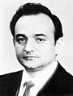 | 31 Dec 1980 - 24 Dec 1985 Ivan Grigoryevich Ustiyan  (Ion Ustian) (b. 1939) PCM
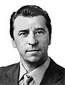 | 24 Dec 1985 - 10 Jan 1990 Ivan Petrovich Kalin  (Ivan Petru Călin) (s.a.) PCM
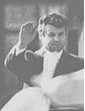 | 10 Jan 1990 - 24 May 1990 Pyotr Andreyevich Paskar  (Petru Andrei Pascari) (2nd time) (s.a.) PCM
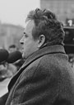 | 25 May 1990 - 5 Jun 1990 Mircha Georgiyevich Druk  (Mircea Gheorghe Druc) (b. 1941) FPM
Prime ministers
5 Jun 1990 - 28 May 1991 Mircea Gheorghe Druc
(s.a.) FPM
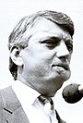 | 28 May 1991 - 27 Aug 1991 Valeriu Tudor Muravschi  (Valeriy Fyodorovich Muravskiy)  (b. 1949 - d. 2020) FPM
Party abbreviations: FPM = Frontul Popular din Moldova (Popular Front of Moldova, Moldovan/Romanian nationalist, succeeded by Christian Democratic Popular Front, 1989-1992); PCM = Partiya Kommunisticheskaya Moldovey/Partidulul Comunist al Moldovei (Communist Party of Moldovia, communist, former PCM-B, from Jun 1990 Communist Party of Moldova, 13 Oct 1952-23 Aug 1991, banned 1991-93);
- Former parties: KPU-B = Komunistychna Partiya (Bil'shovykiv) Ukraïny/Kommunisticheskaya Partiya (Bol'shevikov) Ukrainy/Partidul Komunist al Ukrainej (Communist Party [Bolsheviks] of Ukraine, communist, 1 Mar 1919 separated from Russian Communist Party, Jul 1918-13 Oct 1952, renamed Komunistychna Partiya Ukraïny [Communist Party of Ukraine]); PCM-B = Partidului Comunist (Bolşevic) din Moldova/Kommunisticheskaya Partiya (Bol'shevikov) Moldavii (Communist Party [Bolsheviks] of Moldavia, communist, 15 Aug 1940-13 Oct 1952, renamed PCM)
Moldova
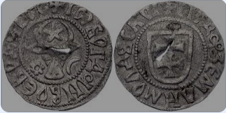
Moldova 1 Groschen 1504 - 1517 (ND) Bogdan III
INCLUDEPICTURE "http://upload.wikimedia.org/wikipedia/commons/thumb/a/af/Stamp_of_Moldova_189.gif/220px-Stamp_of_Moldova_189.gif" \* MERGEFORMATINET INCLUDEPICTURE "http://upload.wikimedia.org/wikipedia/commons/thumb/a/af/Stamp_of_Moldova_189.gif/220px-Stamp_of_Moldova_189.gif" \* MERGEFORMATINET INCLUDEPICTURE "http://upload.wikimedia.org/wikipedia/commons/thumb/a/af/Stamp_of_Moldova_189.gif/220px-Stamp_of_Moldova_189.gif" \* MERGEFORMATINET 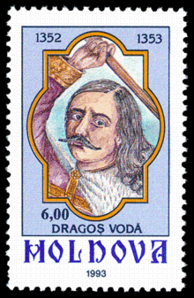 |  |  |  |  |  | INCLUDEPICTURE "http://upload.wikimedia.org/wikipedia/commons/thumb/d/df/Stamp_of_Moldova_244.gif/220px-Stamp_of_Moldova_244.gif" \* MERGEFORMATINET INCLUDEPICTURE "http://upload.wikimedia.org/wikipedia/commons/thumb/d/df/Stamp_of_Moldova_244.gif/220px-Stamp_of_Moldova_244.gif" \* MERGEFORMATINET INCLUDEPICTURE "http://upload.wikimedia.org/wikipedia/commons/thumb/d/df/Stamp_of_Moldova_244.gif/220px-Stamp_of_Moldova_244.gif" \* MERGEFORMATINET 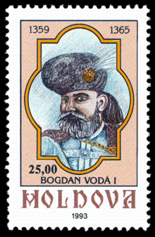
INCLUDEPICTURE "http://upload.wikimedia.org/wikipedia/commons/thumb/5/5d/Stamp_of_Moldova_171.gif/220px-Stamp_of_Moldova_171.gif" \* MERGEFORMATINET INCLUDEPICTURE "http://upload.wikimedia.org/wikipedia/commons/thumb/5/5d/Stamp_of_Moldova_171.gif/220px-Stamp_of_Moldova_171.gif" \* MERGEFORMATINET INCLUDEPICTURE "http://upload.wikimedia.org/wikipedia/commons/thumb/5/5d/Stamp_of_Moldova_171.gif/220px-Stamp_of_Moldova_171.gif" \* MERGEFORMATINET 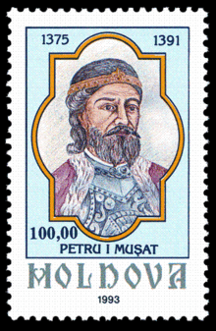 |  |  |  |  |  | INCLUDEPICTURE "http://upload.wikimedia.org/wikipedia/commons/thumb/7/70/Stamp_of_Moldova_319.gif/220px-Stamp_of_Moldova_319.gif" \* MERGEFORMATINET INCLUDEPICTURE "http://upload.wikimedia.org/wikipedia/commons/thumb/7/70/Stamp_of_Moldova_319.gif/220px-Stamp_of_Moldova_319.gif" \* MERGEFORMATINET INCLUDEPICTURE "http://upload.wikimedia.org/wikipedia/commons/thumb/7/70/Stamp_of_Moldova_319.gif/220px-Stamp_of_Moldova_319.gif" \* MERGEFORMATINET 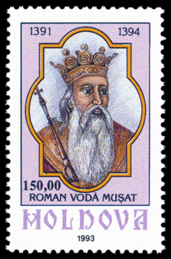
INCLUDEPICTURE "http://upload.wikimedia.org/wikipedia/commons/thumb/c/c9/Stamp_of_Moldova_345.gif/220px-Stamp_of_Moldova_345.gif" \* MERGEFORMATINET INCLUDEPICTURE "http://upload.wikimedia.org/wikipedia/commons/thumb/c/c9/Stamp_of_Moldova_345.gif/220px-Stamp_of_Moldova_345.gif" \* MERGEFORMATINET INCLUDEPICTURE "http://upload.wikimedia.org/wikipedia/commons/thumb/c/c9/Stamp_of_Moldova_345.gif/220px-Stamp_of_Moldova_345.gif" \* MERGEFORMATINET 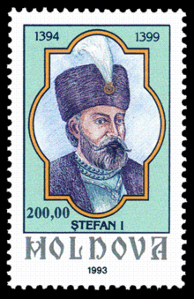 |  |  |  |  |  | 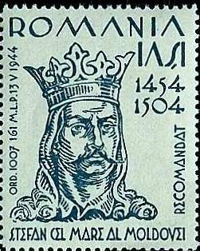
INCLUDEPICTURE "http://upload.wikimedia.org/wikipedia/commons/9/9c/Stamp_of_Moldova_440.gif" \* MERGEFORMATINET INCLUDEPICTURE "http://upload.wikimedia.org/wikipedia/commons/9/9c/Stamp_of_Moldova_440.gif" \* MERGEFORMATINET INCLUDEPICTURE "http://upload.wikimedia.org/wikipedia/commons/9/9c/Stamp_of_Moldova_440.gif" \* MERGEFORMATINET 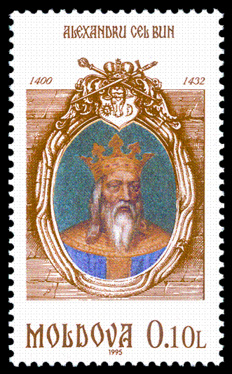 |  |  |  |  |  | INCLUDEPICTURE "http://upload.wikimedia.org/wikipedia/commons/0/0b/Stamp_of_Moldova_278.gif" \* MERGEFORMATINET INCLUDEPICTURE "http://upload.wikimedia.org/wikipedia/commons/0/0b/Stamp_of_Moldova_278.gif" \* MERGEFORMATINET INCLUDEPICTURE "http://upload.wikimedia.org/wikipedia/commons/0/0b/Stamp_of_Moldova_278.gif" \* MERGEFORMATINET 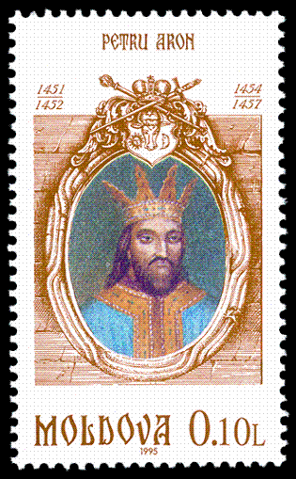
INCLUDEPICTURE "http://upload.wikimedia.org/wikipedia/commons/b/bb/Stamp_of_Moldova_361.gif" \* MERGEFORMATINET INCLUDEPICTURE "http://upload.wikimedia.org/wikipedia/commons/b/bb/Stamp_of_Moldova_361.gif" \* MERGEFORMATINET INCLUDEPICTURE "http://upload.wikimedia.org/wikipedia/commons/b/bb/Stamp_of_Moldova_361.gif" \* MERGEFORMATINET 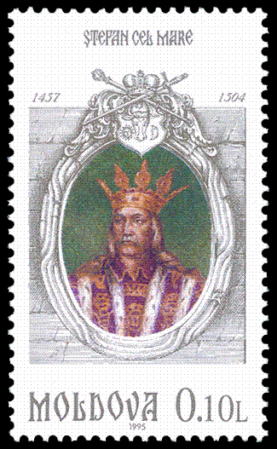 |  |  |  |  |  | INCLUDEPICTURE "http://upload.wikimedia.org/wikipedia/commons/8/83/Stamp_of_Moldova_395.gif" \* MERGEFORMATINET INCLUDEPICTURE "http://upload.wikimedia.org/wikipedia/commons/8/83/Stamp_of_Moldova_395.gif" \* MERGEFORMATINET INCLUDEPICTURE "http://upload.wikimedia.org/wikipedia/commons/8/83/Stamp_of_Moldova_395.gif" \* MERGEFORMATINET 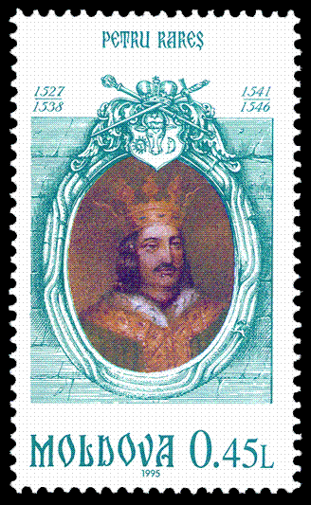
INCLUDEPICTURE "http://upload.wikimedia.org/wikipedia/commons/thumb/8/81/Stamp_of_Moldova_143.gif/220px-Stamp_of_Moldova_143.gif" \* MERGEFORMATINET INCLUDEPICTURE "http://upload.wikimedia.org/wikipedia/commons/thumb/8/81/Stamp_of_Moldova_143.gif/220px-Stamp_of_Moldova_143.gif" \* MERGEFORMATINET INCLUDEPICTURE "http://upload.wikimedia.org/wikipedia/commons/thumb/8/81/Stamp_of_Moldova_143.gif/220px-Stamp_of_Moldova_143.gif" \* MERGEFORMATINET 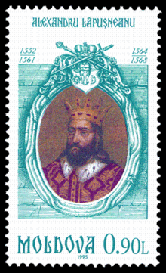 |  |  |  |  |  | INCLUDEPICTURE "http://dic.academic.ru/pictures/wiki/files/83/Stamp_of_Moldova_324.gif" \* MERGEFORMATINET INCLUDEPICTURE "http://dic.academic.ru/pictures/wiki/files/83/Stamp_of_Moldova_324.gif" \* MERGEFORMATINET INCLUDEPICTURE "http://dic.academic.ru/pictures/wiki/files/83/Stamp_of_Moldova_324.gif" \* MERGEFORMATINET 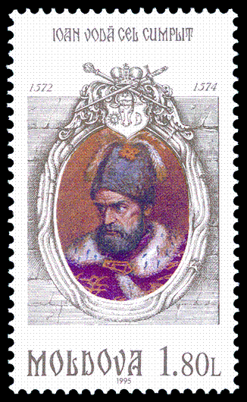
INCLUDEPICTURE "http://upload.wikimedia.org/wikipedia/commons/f/fe/Stamp_of_Moldova_186.gif" \* MERGEFORMATINET INCLUDEPICTURE "http://upload.wikimedia.org/wikipedia/commons/f/fe/Stamp_of_Moldova_186.gif" \* MERGEFORMATINET INCLUDEPICTURE "http://upload.wikimedia.org/wikipedia/commons/f/fe/Stamp_of_Moldova_186.gif" \* MERGEFORMATINET 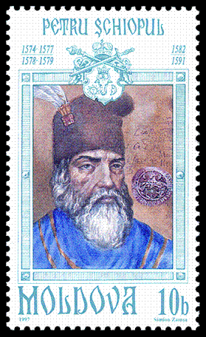 |  |  |  |  |  | INCLUDEPICTURE "http://upload.wikimedia.org/wikipedia/commons/3/3b/Stamp_of_Moldova_192.gif" \* MERGEFORMATINET INCLUDEPICTURE "http://upload.wikimedia.org/wikipedia/commons/3/3b/Stamp_of_Moldova_192.gif" \* MERGEFORMATINET INCLUDEPICTURE "http://upload.wikimedia.org/wikipedia/commons/3/3b/Stamp_of_Moldova_192.gif" \* MERGEFORMATINET 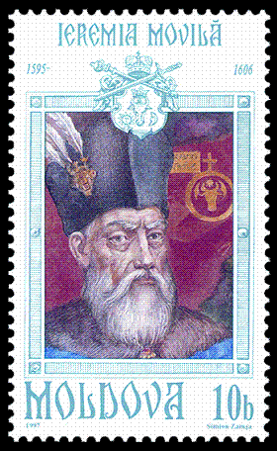
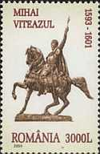 |  |  |  |  |  | INCLUDEPICTURE "http://upload.wikimedia.org/wikipedia/commons/3/34/Stamp_of_Moldova_255.gif" \* MERGEFORMATINET INCLUDEPICTURE "http://upload.wikimedia.org/wikipedia/commons/3/34/Stamp_of_Moldova_255.gif" \* MERGEFORMATINET INCLUDEPICTURE "http://upload.wikimedia.org/wikipedia/commons/3/34/Stamp_of_Moldova_255.gif" \* MERGEFORMATINET 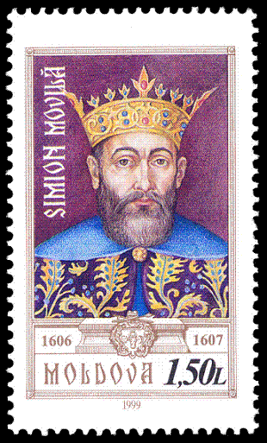
INCLUDEPICTURE "http://upload.wikimedia.org/wikipedia/commons/4/42/Stamp_of_Moldova_229.gif" \* MERGEFORMATINET INCLUDEPICTURE "http://upload.wikimedia.org/wikipedia/commons/4/42/Stamp_of_Moldova_229.gif" \* MERGEFORMATINET INCLUDEPICTURE "http://upload.wikimedia.org/wikipedia/commons/4/42/Stamp_of_Moldova_229.gif" \* MERGEFORMATINET 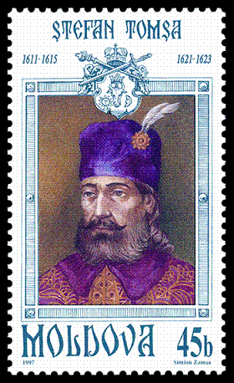 |  |  |  |  |  | INCLUDEPICTURE "http://upload.wikimedia.org/wikipedia/commons/9/92/Stamp_of_Moldova_444.gif" \* MERGEFORMATINET INCLUDEPICTURE "http://upload.wikimedia.org/wikipedia/commons/9/92/Stamp_of_Moldova_444.gif" \* MERGEFORMATINET INCLUDEPICTURE "http://upload.wikimedia.org/wikipedia/commons/9/92/Stamp_of_Moldova_444.gif" \* MERGEFORMATINET 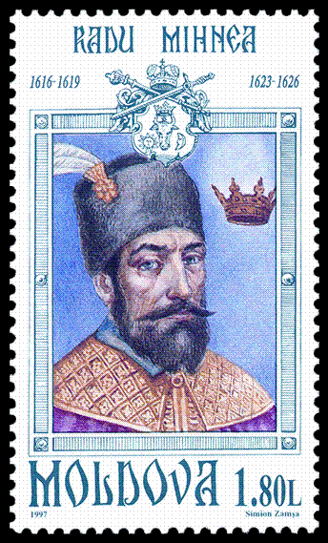
INCLUDEPICTURE "http://upload.wikimedia.org/wikipedia/commons/thumb/8/80/Stamp_of_Moldova_423.gif/150px-Stamp_of_Moldova_423.gif" \* MERGEFORMATINET INCLUDEPICTURE "http://upload.wikimedia.org/wikipedia/commons/thumb/8/80/Stamp_of_Moldova_423.gif/150px-Stamp_of_Moldova_423.gif" \* MERGEFORMATINET INCLUDEPICTURE "http://upload.wikimedia.org/wikipedia/commons/thumb/8/80/Stamp_of_Moldova_423.gif/150px-Stamp_of_Moldova_423.gif" \* MERGEFORMATINET 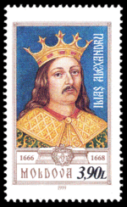 |  |  |  |  |  | INCLUDEPICTURE "http://upload.wikimedia.org/wikipedia/commons/3/37/Stamp_of_Moldova_362.gif" \* MERGEFORMATINET INCLUDEPICTURE "http://upload.wikimedia.org/wikipedia/commons/3/37/Stamp_of_Moldova_362.gif" \* MERGEFORMATINET INCLUDEPICTURE "http://upload.wikimedia.org/wikipedia/commons/3/37/Stamp_of_Moldova_362.gif" \* MERGEFORMATINET 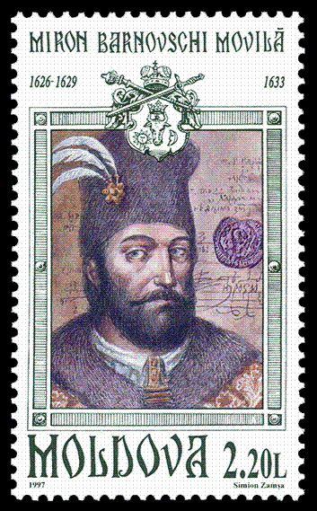
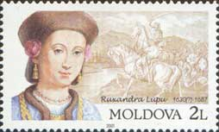
INCLUDEPICTURE "http://upload.wikimedia.org/wikipedia/commons/7/79/Stamp_of_Moldova_273.gif" \* MERGEFORMATINET INCLUDEPICTURE "http://upload.wikimedia.org/wikipedia/commons/7/79/Stamp_of_Moldova_273.gif" \* MERGEFORMATINET INCLUDEPICTURE "http://upload.wikimedia.org/wikipedia/commons/7/79/Stamp_of_Moldova_273.gif" \* MERGEFORMATINET 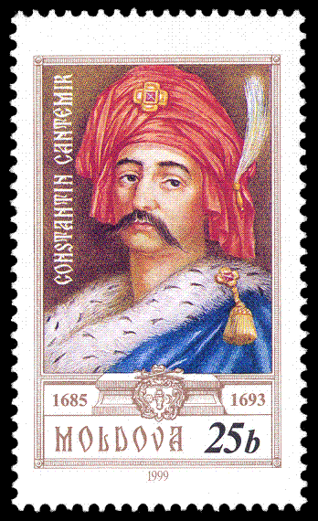 |  |  |  |  |  | INCLUDEPICTURE "http://upload.wikimedia.org/wikipedia/commons/a/a0/Stamp_of_Moldova_md412.jpg" \* MERGEFORMATINET INCLUDEPICTURE "http://upload.wikimedia.org/wikipedia/commons/a/a0/Stamp_of_Moldova_md412.jpg" \* MERGEFORMATINET INCLUDEPICTURE "http://upload.wikimedia.org/wikipedia/commons/a/a0/Stamp_of_Moldova_md412.jpg" \* MERGEFORMATINET 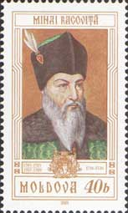
INCLUDEPICTURE "http://upload.wikimedia.org/wikipedia/commons/1/16/Stamp_of_Moldova_RM441.jpg" \* MERGEFORMATINET INCLUDEPICTURE "http://upload.wikimedia.org/wikipedia/commons/1/16/Stamp_of_Moldova_RM441.jpg" \* MERGEFORMATINET INCLUDEPICTURE "http://upload.wikimedia.org/wikipedia/commons/1/16/Stamp_of_Moldova_RM441.jpg" \* MERGEFORMATINET 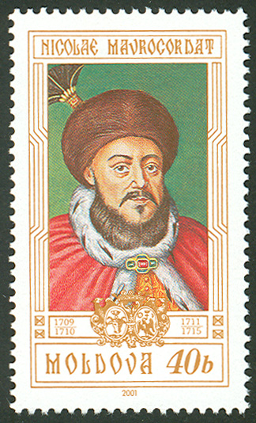 |  |  |  |  |  | INCLUDEPICTURE "http://upload.wikimedia.org/wikipedia/commons/a/ad/Stamp_of_Moldova_RM442.jpg" \* MERGEFORMATINET INCLUDEPICTURE "http://upload.wikimedia.org/wikipedia/commons/a/ad/Stamp_of_Moldova_RM442.jpg" \* MERGEFORMATINET INCLUDEPICTURE "http://upload.wikimedia.org/wikipedia/commons/a/ad/Stamp_of_Moldova_RM442.jpg" \* MERGEFORMATINET 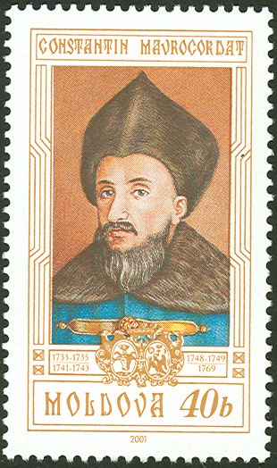
INCLUDEPICTURE "http://upload.wikimedia.org/wikipedia/commons/5/50/Stamp_of_Moldova_RM443..jpg" \* MERGEFORMATINET INCLUDEPICTURE "http://upload.wikimedia.org/wikipedia/commons/5/50/Stamp_of_Moldova_RM443..jpg" \* MERGEFORMATINET INCLUDEPICTURE "http://upload.wikimedia.org/wikipedia/commons/5/50/Stamp_of_Moldova_RM443..jpg" \* MERGEFORMATINET 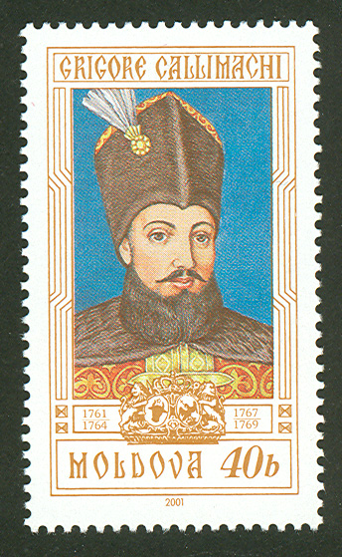 |  |  |  |  |  | INCLUDEPICTURE "http://upload.wikimedia.org/wikipedia/commons/a/a8/Stamp_of_Moldova_RM444.jpg" \* MERGEFORMATINET INCLUDEPICTURE "http://upload.wikimedia.org/wikipedia/commons/a/a8/Stamp_of_Moldova_RM444.jpg" \* MERGEFORMATINET INCLUDEPICTURE "http://upload.wikimedia.org/wikipedia/commons/a/a8/Stamp_of_Moldova_RM444.jpg" \* MERGEFORMATINET 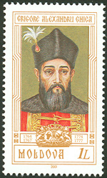
INCLUDEPICTURE "http://upload.wikimedia.org/wikipedia/commons/thumb/1/15/Stamp_of_Moldova_md631.jpg/150px-Stamp_of_Moldova_md631.jpg" \* MERGEFORMATINET INCLUDEPICTURE "http://upload.wikimedia.org/wikipedia/commons/thumb/1/15/Stamp_of_Moldova_md631.jpg/150px-Stamp_of_Moldova_md631.jpg" \* MERGEFORMATINET INCLUDEPICTURE "http://upload.wikimedia.org/wikipedia/commons/thumb/1/15/Stamp_of_Moldova_md631.jpg/150px-Stamp_of_Moldova_md631.jpg" \* MERGEFORMATINET 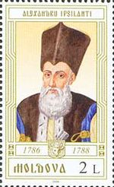 |  |  |  |  |  | INCLUDEPICTURE "http://upload.wikimedia.org/wikipedia/commons/thumb/8/89/Stamp_of_Moldova_md633.jpg/150px-Stamp_of_Moldova_md633.jpg" \* MERGEFORMATINET INCLUDEPICTURE "http://upload.wikimedia.org/wikipedia/commons/thumb/8/89/Stamp_of_Moldova_md633.jpg/150px-Stamp_of_Moldova_md633.jpg" \* MERGEFORMATINET INCLUDEPICTURE "http://upload.wikimedia.org/wikipedia/commons/thumb/8/89/Stamp_of_Moldova_md633.jpg/150px-Stamp_of_Moldova_md633.jpg" \* MERGEFORMATINET 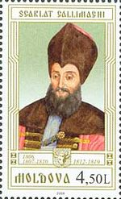
INCLUDEPICTURE "http://upload.wikimedia.org/wikipedia/commons/thumb/9/9b/Stamp_of_Moldova_md628.jpg/150px-Stamp_of_Moldova_md628.jpg" \* MERGEFORMATINET INCLUDEPICTURE "http://upload.wikimedia.org/wikipedia/commons/thumb/9/9b/Stamp_of_Moldova_md628.jpg/150px-Stamp_of_Moldova_md628.jpg" \* MERGEFORMATINET INCLUDEPICTURE "http://upload.wikimedia.org/wikipedia/commons/thumb/9/9b/Stamp_of_Moldova_md628.jpg/150px-Stamp_of_Moldova_md628.jpg" \* MERGEFORMATINET 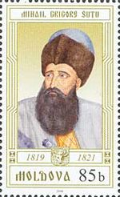 |  |  |  |  |  | INCLUDEPICTURE "http://upload.wikimedia.org/wikipedia/commons/5/57/Stamp_of_Moldova_md632.jpg" \* MERGEFORMATINET INCLUDEPICTURE "http://upload.wikimedia.org/wikipedia/commons/5/57/Stamp_of_Moldova_md632.jpg" \* MERGEFORMATINET INCLUDEPICTURE "http://upload.wikimedia.org/wikipedia/commons/5/57/Stamp_of_Moldova_md632.jpg" \* MERGEFORMATINET 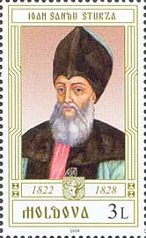
INCLUDEPICTURE "http://upload.wikimedia.org/wikipedia/commons/f/f9/Stamp_of_Moldova_md630.jpg" \* MERGEFORMATINET INCLUDEPICTURE "http://upload.wikimedia.org/wikipedia/commons/f/f9/Stamp_of_Moldova_md630.jpg" \* MERGEFORMATINET INCLUDEPICTURE "http://upload.wikimedia.org/wikipedia/commons/f/f9/Stamp_of_Moldova_md630.jpg" \* MERGEFORMATINET 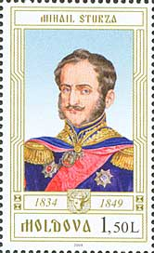 |  |  |  |  |  | INCLUDEPICTURE "http://upload.wikimedia.org/wikipedia/commons/9/9e/Stamp_of_Moldova_md629.jpg" \* MERGEFORMATINET INCLUDEPICTURE "http://upload.wikimedia.org/wikipedia/commons/9/9e/Stamp_of_Moldova_md629.jpg" \* MERGEFORMATINET INCLUDEPICTURE "http://upload.wikimedia.org/wikipedia/commons/9/9e/Stamp_of_Moldova_md629.jpg" \* MERGEFORMATINET 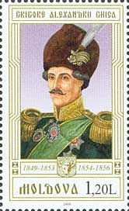
INCLUDEPICTURE "http://upload.wikimedia.org/wikipedia/commons/6/67/Moldavian_Stamp_with_the_Portrait_of_Alexandru_Ioan_Cuza_by_August_Strixner.jpg" \* MERGEFORMATINET INCLUDEPICTURE "http://upload.wikimedia.org/wikipedia/commons/6/67/Moldavian_Stamp_with_the_Portrait_of_Alexandru_Ioan_Cuza_by_August_Strixner.jpg" \* MERGEFORMATINET INCLUDEPICTURE "http://upload.wikimedia.org/wikipedia/commons/6/67/Moldavian_Stamp_with_the_Portrait_of_Alexandru_Ioan_Cuza_by_August_Strixner.jpg" \* MERGEFORMATINET 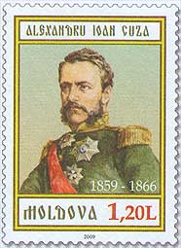
Stadholders of Bessarabia (title Namestnik)(with rights of governor-general)
26 May 1816 - 15 Jun 1820 Aleksey Nikolayevich Bakhmetyev (b. 1774 - d. 1841)
15 Jun 1820 - 17 Jul 1822 Ivan Nikitich Inzov (b. 1768 – d. 1845)
Governors-general of Novorossiya and Bessarabia (in Odessa)
17 Jul 1822 - 1874 the Governors-general of Novorossiya
Russian Governors of Bessarabia [dates in OS style calendar]
23 Jul 1812 - 17 Jun 1813 Skarlat Dmitriyevich Sturdza
(= Scarlat Dimitrie Sturdza) (b. c.1750 - d. 1816)
17 Jun 1813 - Oct 1817 Ivan Markovich Garting
(Johann Festus Harting) (b. 1768 - d. 1831)
Oct 1817 - 30 Dec 1817 Matvey Yegorovich Krupenskiy
(b. 1775 - d. 1855) (acting)
30 Dec 1817 - 11 May 1818 Konstantin Antonovich Katakazi
(Constantin Catacazi) (b. 1775 - d. 1826)
Russian Governors of Bessarabia Oblast (from 1873, Guberniya)[dates in OS style calendar]
11 May 1818 - 26 Aug 1825 Konstantin Antonovich Katakazi (s.a.)
4 Sep 1825 - 12 Jan 1828 Vasiliy Fyodorovich Timkovskiy (b. 1781 - d. 1832)
17 Jan 1828 - 30 Jul 1828 Aleksandr Mikhaylovich Turgenev (b. 1772 - d. 1863)
30 Jul 1828 - 2 Nov 1828 Yevgraf Nikiforovich Golubtsov
(b. 1777 - d. 1835) (acting)
2 Nov 1828 - 24 Mar 1829 Nikolay Prokofyevich Prazhevskiy (b. 1787 - d. 1849)
24 Mar 1829 - 17 Apr 1833 Akinfiy Ivanovich Sorokunskiy (b. 1781 - d. 18..)
16 Jul 1833 - 28 Aug 1834 Pavel Ivanovich Averin (b. 1775 - d. 1849)
28 Aug 1834 - 29 May 1854 Pavel Ivanovich Fyodorov (b. 1791 - d. 1855)
15 Jul 1854 - 10 Nov 1857 Mikhail Sergeyevich Ilinskiy (d. 1865)
10 Nov 1857 - 19 Dec 1862 Mikhail L'vovich Fanton-de-Verrayon(b. 1804 - d. 1887)
28 Dec 1862 - 1 Aug 1863 Ivan Osipovich Baron Velio (b. 1830 - d. 1899)
1 Aug 1863 - 30 Nov 1867 Platon Aleksandrovich Antonovich (b. 1811 - d. 1883)
5 Dec 1867 - 3 Jun 1871 Yegor Yegorovich Gangard (Gangardt)(b. 1812 - d. 1882)
3 Jun 1871 - 27 Feb 1879 Nikolay Ignatyevich Shebeko (b. 1834 - d. 1905)
27 Feb 1879 - 15 May 1879 Sergey Fyodorovich Tanskiy (acting)(b. 1813 - d. ....)
15 May 1879 - 12 Aug 1881 Evgeniy Osipovich Yankovskiy (b. 1837 - d. 1892)
16 Aug 1881 - 30 Jun 1883 Modest Mavrikiyevich Koniar (b. 1827 - d. 1890)
30 Jun 1883 - 4 Jul 1899 Aleksandr Petrovich Konstantinovich(b. 1832 - d. 1903)
10 Jul 1899 - 30 May 1903 Vikentiy Samoylovich fon Raaben (Vinzenz von Raaben)
(b. 1843 - d. af.1917)
30 May 1903 - 31 Oct 1907 Knyaz' Sergey Dmitriyevich Urusov (b. 1862 - d. 1937)
31 Oct 1904 - 11 Oct 1908 Aleksey Nikolayevich Kharuzin (b. 1864 - d. 1932)
11 Oct 1908 - 7 May 1912 Graf Ivan Viktorovich Kankrin (b. 1860 - d. 1920) RS
7 May 1912 - 22 Sep 1915 Mikhail Eduardovich Gil'khen (Hilchen)
(b. 1868 - d. 1945) Non-party
22 Sep 1915 - 6 Mar 1917 Mikhail Mikhaylovich Voronovich
(b. 1868 - d. 1918) Non-party
Commissars of the Provisional Government in Bessarabia
6 Mar 1917 - Oct 1917 Konstantin Aleksandrovich Mimi
(= Constantin Alexandru Mimi)
(b. 1868 - d. 1935) Non-party
Oct 1917 - 15 Dec 1917 Ivan Konstantinovich Inkulets (= Ion Constantin Inculeţ)
(b. 1884 - d. 1940) PSR
President of the National Diet
15 Dec 1917 - 14 Jan 1918 Ion Constantin Inculeţ (1st time) (s.a.) PSR
Chairman of the Executive Committee of the Soviet of the Bessarabian Governorate
(subordinated to the "Rumcherod" in Odessa)
14 Jan 1918 - 26 Jan 1918 Yakov Denisovich Meleshin (in office Nov 1917 – Mar 1918) (b. 1884 - d. 1918) RSDRP-B
Presidents of the National Diet (also known as the Assembly of the Land)
26 Jan 1918 - 16 Apr 1918 Ion Constantin Inculeţ (2nd time) (s.a.) PSR
16 Apr 1918 - 8 Dec 1918 Constantin Gheorghe Stere (Sterea) (b. 1865 - d. 1936) PTB
8 Dec 1918 - 10 Dec 1918 Pantelimon "Pan" Nicolae Halippa (b. 1883 - d. 1979) PTB
Chairman of the Provisional Workers' and Peasants' Government
(Council of People's Commissars) of Bessarabian S.S.R.
5 May 1919 - 25 Aug 1919 Ivan Nikolayevich Krivorukov
(in Odessa exile to 11 May 1919, then in Tiraspol)
(b. 1883 - d. 1943) RKP
Soviet Commander of the Southern Front
28 Jun 1940 - 2 Aug 1940 Georgiy Konstantinovich Zhukov (b. 1896 - d. 1974) Mil
Chairman of the Bessarabia Provisional Revolutionary Committee
28 Jun 1940 - 2 Aug 1940 Sergey Danilovich Burlachenko (b. 1899 - d. 1962) KPU-B
Romanian Commandant (of the 4th Army)
16 Jul 1941 - 31 Jul 1941 Nicolae Ciupercă (b. 1882 - d. 1950) Mil
Governors of Bessarabia
1 Aug 1941 - 15 Apr 1943 Constantin Gheorghe Voiculescu (b. 1890 - d. 1955) Mil
15 Apr 1943 - 23 Aug 1944 Olimpiu Stavrat (b. 1888 - d. 1968) Mil
Presidents
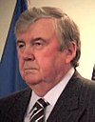 | 27 Apr 1990 - 15 Jan 1997 Mircea Ion Snegur  (president of the Supreme Soviet to 3 Sep 1990) Non-party  (b. 1940 - d. 2023) PCM;Jun 1990
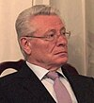 | 15 Jan 1997 - 7 Apr 2001 Petru Chiril Lucinschi  (b. 1940) PCRM
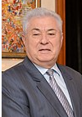 | 7 Apr 2001 - 11 Sep 2009 Vladimir Nicolae Voronin  (b. 1941) PCRM
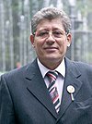 | 11 Sep 2009 - 28 Dec 2010 Mihai Toader Ghimpu (acting)  (b. 1951) PL
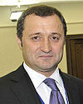 | 28 Dec 2010 - 30 Dec 2010 Vladimir Vasile Filat (acting)  (b. 1969) PLDM
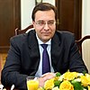 | 30 Dec 2010 - 23 Mar 2012 Marian Ilie Lupu (acting)  (b. 1966) PDM
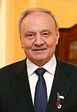 | 23 Mar 2012 - 23 Dec 2016 Nicolae Vasile Timofti (b. 1948) Non-party
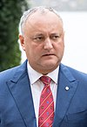 | 23 Dec 2016 - 24 Dec 2020 Igor Dodon  (b. 1975) PSRM
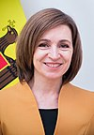 |  |  | 24 Dec 2020 - Maia Sandu (f) (b. 1972) PAS
Chairmen of the General Directory
21 Dec 1917 - 1 Feb 1918 Pantelimon Vasile Erhan (b. 1884 - d. 1971) PSR
1 Feb 1918 - 9 Apr 1918 Daniel Alexandru Ciuhureanu (b. 1885 - d. 1950) PNM
9 Apr 1918 - 10 Dec 1918 Petru Cazacu (b. 1873 - d. 1956) PNM
Prime ministers
26 May 1990 - 28 May 1991 Mircea Druc
(chairman of the council of ministers to 5 Jun 1990)
(b. 1941) FPM
28 May 1991 - 1 Jul 1992 Valeriu Tudor Muravschi
(b. 1949 - d. 2020) FPM
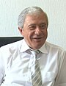 |  | 1 Jul 1992 - 25 Jan 1997 Andrei Nicolae Sangheli  (b. 1944) PDAM
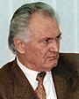 |  | 25 Jan 1997 - 12 Mar 1999 Ion Condratie Ciubuc  (b. 1943 - d. 2018) Non-party
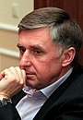 |  | 12 Mar 1999 - 21 Dec 1999 Ion Mihai Sturza  (b. 1960) Non-party
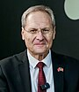 |  | 21 Dec 1999 - 20 Apr 2001 Dumitru Petru Braghiş  (b. 1957) Non-party
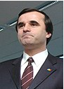 |  | 20 Apr 2001 - 31 Mar 2008 Vasile Petru Tarlev  (b. 1963) PCRM
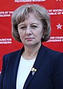 |  | 31 Mar 2008 - 14 Sep 2009 Zinaida Petru Greceanîi (f)  (b. 1956) PCRM
14 Sep 2009 - 25 Sep 2009 Vitalie Vasile Pîrlog (acting)
(b. 1974) PCRM
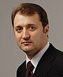 |  | 25 Sep 2009 - 25 Apr 2013 Vladimir Vasile Filat  (s.a.) PLDM
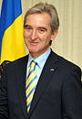 |  | 25 Apr 2013 - 18 Feb 2015 Iurie Leancă  (acting to 31 May 2013)  (b. 1963) PLDM
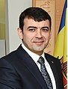 |  | 18 Feb 2015 - 22 Jun 2015 Chiril Gaburici  (b. 1976) Non-party
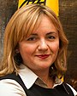 |  | 22 Jun 2015 - 30 Jul 2015 Natalia Gherman (f) (acting)  (b. 1969) PLDM
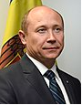 |  | 30 Jul 2015 - 30 Oct 2015 Valeriu Streleț  (b. 1970) PLDM
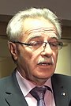 |  | 30 Oct 2015 - 20 Jan 2016 Gheorghe Brega (acting)  (b. 1951) PL
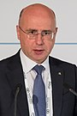 |  | 20 Jan 2016 - 14 Jun 2019 Pavel Filip  (b. 1966) PDM
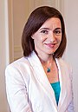 |  | 8 Jun 2019 - 14 Nov 2019 Maia Sandu (f)  (not recognized by Constitutional Court until 15 Jun 2019)  (s.a.) PAS
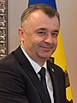 |  | 14 Nov 2019 - 31 Dec 2020 Ion Chicu  (b. 1972) Non-party
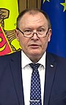 |  | 1 Jan 2021 - 6 Aug 2021 Aureliu Ciocoi (acting)  (b. 1968) Non-party
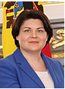 |  | 6 Aug 2021 - 16 Feb 2023 Natalia Gavrilița (f)  (b. 1977) PAS
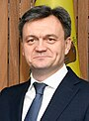 |  | 16 Feb 2023 - Dorin Recean  (b. 1974) Non-party
Territorial Disputes: Moldova and Ukraine operate joint customs posts to monitor the transit of people and commodities through Moldova's break-away Transnistria region, which remains under the auspices of an Organization for Security and Cooperation in Europe (OSCE)-mandated peacekeeping mission comprised of Moldovan, Transnistrian, Russian, and Ukrainian troops.
Party abbreviations: PAS = Partidul Acțiune și Solidaritate (Party of Action and Solidarity, center-right, social liberal, pro-European, est.15 May 2016); PCRM = Partidul Comuniştilor din Republica Moldova (Party of Communists of the Republic of Moldova, communist, Eurosceptic, former PCM, est.22 Oct 1993); PDM = Partidul Democrat din Moldova (Democratic Party of Moldova, center-left, est.8 Feb 1997); PL = Partidul Liberal (Liberal Party, liberal-conservative, 5 Sep 1993-24 Apr 2005 named Party of Reform, est.5 Sep 1993); PLDM = Partidul Liberal Democrat din Moldova (Liberal Democratic Party of Moldova, center-right, est.8 Dec 2007); PSRM = Partidul Socialiștilor din Republica Moldova/Partiya Sotsialistov Respubliki Moldova (Party of Socialists of the Republic of Moldova, democratic-socialist, social conservative, populist, pro-Russia, Eurosceptic, 2005-2011 named Party of Socialists of Moldova "Motherland" [Partidul Socialiștilor din Moldova "Patria-Rodina"], split from PSM, est.29 Jan 1997); Mil = Military;
- Former parties: FPM = Frontul Popular din Moldova (Popular Front of Moldova, Moldovan/ Romanian nationalist, succeeded by Christian Democratic Popular Front, 20 May 1989-15 Feb 1992); KPU-B = Komunistychna Partiya (Bil'shovykiv) Ukraïny/Kommunisticheskaya Partiya (Bol'shevikov) Ukrainy/Partidul Komunist al Ukrainej (Communist Party [Bolsheviks] of Ukraine, communist, 1 Mar 1919 separated from Russian Communist Party, Jul 1918-13 Oct 1952, renamed Komunistychna Partiya Ukraïny [Communist Party of Ukraine]); PNM = Partidul Naţional Moldovenesc (Moldovan National Party, Mar 1917-23 Aug 1918, merged into PTB); PCM = Partidul Comunist al Moldovei (Communist Party of Moldovia, communist, former PCM-B, from Jun 1990 Communist Party of Moldova, 13 Oct 1952-23 Aug 1991, banned 1991-93, then PCRM); PDAM = Partidul Democrat Agrar din Moldova (Democratic Agrarian Party of Moldova, agrarian, 19 Oct 1991-10 Jul 2004, renamed Partidul Agrar din Moldova); PTB = Partidul Ţărănesc din Basarabia (Bessarabian Peasants' Party, split from PNM, 23 Aug 1918-20 Jan 1923, merged into PNL of Romania); RSDRP-B = Rossiyskaya Sotsial-Demokraticheskaya Rabochaya Partiya (Bol'shevikov)(Russian Social Democratic Workers' Party [Bolsheviks] [Majority], Russian revolutionary socialist, Marxist communist, from 8 Nov 1917 state party, 1 Mar 1898-8 Mar 1918, renamed RKP); PSR = Partiya Sotsialistov-Revolyutsionerov/Partidul Socialist Revoluţionar (Party of Socialists-Revolutionaries, "SRs", democratic and agrarian socialist, Left SRs and Bolsheviks referred to mainstream SR party as Right SRs, 1902-1921)
Transnistria (Pridnestrovie)
International Organizations/Treaties: CDRN
Note: Russian names with Moldavian/Romanian in parentheses for the period 1924-1940.
From 1990, names are in Russian which is exclusively used in administration - Ukrainian and (Cyrillic) Moldovan are also official languages, but are not used administratively.
1788 Russian occupation of the area (ceded by the Ottoman Empire
in 1791).
1790 - 1793 Area granted to Black Sea Cossack Host, formed in 1788 (largely
former Zaporozhian Sich Cossacks [see under Ukraine], in 1793 the
Host relocated to Kuban), headquarters in Slobodzeya (Slobozia).
20 Nov 1917 Part of the Ukrainian People's Republic.
30 Jan 1918 Under "Rumcherod" (from 31 Jan 1918, Odessa Soviet Republic).
11 Mar 1918 - Dec 1918 Under Austro-Hungarian occupation, part of Ukraine.
9 Feb 1919 - 18 Apr 1919 Tiraspol (Tiraspol') occupied by Polish units of the Allied
forces in Odessa.
18 Apr 1919 - 25 Aug 1919 Tiraspol occupied by Soviet Russia, part of the Ukrainian S.S.R.
25 Aug 1919 - 12 Feb 1920 Tiraspol occupied by "White" Russian Armed forces in the South of
Russia under Denikin.
12 Feb 1920 Transnistria incorporated into Ukrainian S.S.R.
12 Oct 1924 Moldavian Autonomous Socialist Soviet Republic (Moldavskaya
Avtonomnaya Sotsialisticheskaya Sovetskaya Respublika)
established within the Ukrainian S.S.R. by the Soviet Union.
5 Dec 1936 Renamed Moldavian Autonomous Soviet Socialist Republic (Moldavskaya
Avtonomnaya Sovetskaya Sotsialisticheskaya Respublika).
12 Aug 1939 Russian alphabet re-introduced for Moldavian.
2 Aug 1940 Moldavian A.S.S.R. united with Bessarabia (previously part
Romania) to form Moldavian Soviet Socialist Republic (see above).
8 Aug 1941 Tiraspol occupied by Romania.
8 Aug 1941 - 12 Apr 1944 Occupied by Rumania, as part of the Transnistria governorate
(Guvernământul Transnistriei)(see under Ukraine).
12 Apr 1944 Tiraspol is liberated by Soviet forces.
2 Sep 1990 Pridnestrovian (Transnistrian) Moldavian Soviet Socialist Republic
(Pridnestrovskaya Moldavskaya Sovetskaya Sotsialisticheskaya
Respublika) declares secession from Moldova S.S.R., but within
the Soviet Union (not recognized by Moldova S.S.R. or USSR).
22 Sep 1990 Declarations voided by the decree of the President of Soviet Union.
8 Dec 1990 Declaration of sovereignty of the PMSSR passed.
22 Dec 1990 Soviet Union government invalidates sovereignty declaration.
25 Aug 1991 Declaration of independence (not internationally recognized; only
recognized and by the unrecognized states of Abkhazia, South
Ossetia, and Nagorno-Karabakh [on 17 Nov 2006])).
5 Nov 1991 Pridnestrovian (Transnistrian) Moldavian Republic
(Pridnestrovskaya Moldavskaya Respublika).
22 Jul 2005 Transnistria/Pridnestrovie recognized as "an autonomous territorial
unit with special legal status" within Moldova by the government
of Moldova (by law Lege Nr. 173-XVI, LPO173/2005)(not
implemented).
17 Sep 2006 Referendum supports independence from Moldova and association
with Russia by 97.2%
Executive Secretary of the Organizing Bureau of the Communist
Party (Bolsheviks) of Ukraine for the Moldavian A.S.S.R.
15 Oct 1924 - 21 Dec 1924 Iosif Isaakovich Badeyev (Suslik) (b. 1880 - d. 1937)
(Iosif Badeev)
Executive Secretaries of the Moldavian Regional Committee of Communist
Party (Bolsheviks) of Ukraine
21 Dec 1924 - 27 Dec 1928 Iosif Isaakovich Badeyev (Suslik) (s.a.)
(Iosif Badeev)
27 Dec 1928 - 25 Feb 1930 Khaim Bentsionovich Bogopol'skiy (b. 1891 - d. 1937)
(Haim Bogopolski)
25 Feb 1930 - 9 Apr 1930 Vacant
9 Apr 1930 - 2. Oct 1931 Ilya Moiseyevich Ilyin (Broytman) (b. 1893 - d. 1973)
(Ilia Ilin)
2. Oct 1931 - 3 Jul 1932 Ivan Semyonovich Plachinda (b. 1898 - d. 1937)
(Sporosh)(Ivan Semionovici Placinda)
First Secretaries of the Moldavian Regional Committee of the Communist
Party (Bolsheviks) of Ukraine
3 Jul 1932 - 5 Jun 1933 Ivan Nikolayevich Sirko (b. 1900 - d. 1976)
(Ivan Sirko)
5 Jun 1933 - 28 Aug 1935 Gurgen Osipovich Bulat (b. 1900 - d. 1949)
(Gurgen Bulat)
28 Aug 1935 - 17 May 1937 Zinoviy Iosifovich Siderskiy (b. 1897 - d. 1938)
(Zinovie Siderski)
17 May 1937 - 30 Aug 1937 Vladimir Zakharovich Todres (b. 1897 - d. 1959)
(Selektor) (Vladimir Todres)
30 Aug 1937 - 23 May 1938 Nikolay Isayevich Golub' (acting) (b. 1905 - d. 19..)
(Nicolea Golub)
23 May 1938 - 26 Feb 1939 Vladimir Nikolayevich Borisov (b. 1901 - d. 1984)
(Vladimir Borisov)
26 Feb 1939 - 6 Aug 1939 Aleksey Nikolayevich Mel'nikov (b. 1900 - d. 1967)
(Aleksei Melnikov)
6 Aug 1939 - 14 Aug 1940 Pyotr Grigoryevich Borodin (b. 1905 - d. 1986)
(Piotr Borodin)
Atamans of Black Sea Cossack Host (the first of atamans elected by Cossacks)
1788 Sidor Ignatyevich Beliy (b. 1716 - d. 1788)
1788 - 1797 Zakhariy Alekseyevich Chepega (b. 1725 - d. 1797)
Allied (Polish) Commander (of the Polish 4th Rifle Division)
9 Feb 1919 - 18 Apr 1919 Lucjan Żeligowski (b. 1865 - d. 1947) Mil
Chairman of the Moldavian Provisional Revolutionary Committee
9 Nov 1924 - 23 Apr 1925 Grigoriy Ivanovich Staryy (Borisov) (Grigore Borisov)
(b. 1880 - d. 1937) KPU-B
Chairmen of the Central Executive Committee
23 Apr 1925 - 14 May 1926 Grigoriy Ivanovich Staryy (Borisov)
(s.a.) KPU-B
14 May 1926 - May 1937 Yevstafiy Pavlovich Voronovich (Evstafii Voronovici)
(b. 1890 - d. 1937) KPU-B
May 1937 - 18 Jul 1938 Georgiy Yermolayevich Streshnyy
(Gheorghe Streshni) (acting) (b. 1900 - d. 1940) KPU-B
Chairmen of the Presidium of the Supreme Soviet
18 Jul 1938 - 7 Jun 1940 Tikhon Antonovich Konstantinov (b. 1898 - d. 1957) KPU-B
(Tihon Konstantinov)
7 Jun 1940 - 2 Aug 1940 Fyodor Grigoryevich Brovko (b. 1904 - d. 1960) KPU-B
(Fedor Brovko)
Chairman of the (to 29 Nov 1990, Provisional) Supreme Soviet
2 Sep 1990 - 3 Dec 1991 Igor' Nikolayevich Smirnov (b. 1941) OSTK
(Moldovan prisoner 29 Aug - 1 Oct 1991)
29 Aug 1991 - 1 Oct 1991 Andrey Panteleyevich Manoylov (b. 1945 - d. 1995) OSTK
(First deputy, acting for jailed Smirnov)
Presidents
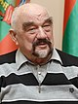 |  |  |  |  | 3 Dec 1991 - 30 Dec 2011 Igor' Nikolayevich Smirnov  (s.a.) Non-party
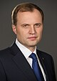 |  |  |  |  | 30 Dec 2011 - 16 Dec 2016 Yevgeniy Vasilyevich Shevchuk  (b. 1968) Non-party
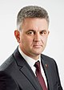 |  |  |  |  | 16 Dec 2016 - Vadim Nikolayevich Krasnosel'skiy  (b. 1970) Non-party
Chairmen of the Council of People's Commissars
23 Apr 1925 - 14 May 1926 Aleksandr Ivanovich Stroyev (b. 1886 - d. 1937) KPU-B
(Aleksei Stroev)
14 May 1926 - 5 Jun 1928 Grigoriy Ivanovich Staryy (Borisov)(s.a.) KPU-B
(1st time)
5 Jun 1928 - 7 Apr 1932 Sergey Vasilyevich Dimitriu (b. 1892 - d. 1937) KPU-B
(Serghei Dimitriu)
7 Apr 1932 - 22 Jun 1937 Grigoriy Ivanovich Staryy (Borisov)(s.a.) KPU-B
(2nd time)
22 Jun 1937 - Feb 1938 ....
Feb 1938 - May 1940 Georgiy Yermolayevich Streshnyy (s.a.) KPU-B
May 1940 - 7 Jun 1940 Fyodor Grigoryevich Brovko (s.a.) KPU-B
(Fedor Brovko)
7 Jun 1940 - 2 Aug 1940 Tikhon Antonovich Konstantinov (s.a.) KPU-B
Chairman of the Council of Ministers
3 Sep 1990 - 29 Nov 1990 Stanislav Ivanovich Moroz (acting) (b. 1938 - d. 2013) PCM
29 Nov 1990 - 18 Jan 2012 Post abolished
Prime ministers (chairmen of the government)
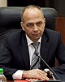 |  |  |  | 18 Jan 2012 - 10 Jul 2013 Pyotr Petrovich Stepanov  (b. 1959) Non-party
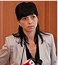 |  |  |  | 10 Jul 2013 - 2 Dec 2015 Tat'yana Mikhaylovna Turanskaya (f)  (Tetyana Mykhaylivna Turans'ka)  (b. 1972) Non-party
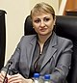 |  |  |  | 13 Oct 2015 - 30 Nov 2015 Mayya Ivanovna Parnas (f)  (acting for Turanskaya)  (b. 1974) Non-party
 |  |  |  | 2 Dec 2015 - 23 Dec 2015 Mayya Ivanovna Parnas (f)(acting) (s.a.) Non-party
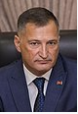 |  |  |  | 23 Dec 2015 - 17 Dec 2016 Pavel Nikolayevich Prokudin  (b. 1966) Non-party
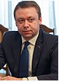 |  |  |  | 17 Dec 2016 - 27 May 2022 Aleksandr Vladimirovich Martynov (b. 1981) Non-party
27 May 2022 - 30 May 2022 Stanislav Mikhaylovich Kasap
(b. 1983) Non-party (acting)
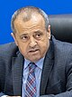 |  |  |  | 30 May 2022 - Aleksandr Nikolayevich Rozenberg  (b. 1967) Non-party
Party abbreviations: KPP = Kommunisticheskaya Partiya Pridnestrovya/Partidul Komunist din Pridnestrov'e (Communist Party of Pridnestrovia, marxist-leninist communist, est.1991); OSTK = Obyedinyonnyy Sovet Trudovyh Kollektivov/Colectivelor Unificate de Muncă (Joint Council of Labor Collectives, pro-govt. trade union group, est.11 Jul 1989); PKP = Pridnestrovskaya Kommunisticheskaya Partiya/Prydnistrovs'ka Komunistychna Partiya/Partidul Komunist din Transnistrya (Pridnestrovian Communist Party, anti-Smirnov communist, est.20 Apr 2003); PPP = Patrioticheskaya Partiya Pridnestrovya/Patriotichna Partiya Pridnistrovya/Partidul Patriotik din Nistreniya (Patriotic Party of Pridnestrovie, Transnistrian nationalist, est.4 Apr 2006); RP = Respublika/Respublika/Republika (Republic, Transnistrian nationalist, Igor Smirnov personalist, est.1990); Mil = Military;
- Former Parties: KPU-B = Komunistychna Partiya (Bil'shovykiv) Ukraïny/Kommunisticheskaya Partiya (Bol'shevikov) Ukrainy/Partidul Komunist al Ukrainej (Communist Party [Bolsheviks] of Ukraine, communist, 1 Mar 1919 separated from Russian Communist Party, Jul 1918-13 Oct 1952, renamed Komunistychna Partiya Ukraïny [Communist Party of Ukraine]); PCM = Partidul Comunist al Moldovei (Communist Party of Moldovia, communist, former PCM-B, from Jun 1990 Communist Party of Moldova, 13 Oct 1952-23 Aug 1991, banned 1991-93, then PCRM); RKP = Rossiyskaya Kommunisticheskaya Partiya (Bol'shevikov)(Russian Communist Party [Bolsheviks], communist, 1918-1925, renamed All-Union Communist Party)
Gagauzia (Gagauz-Yeri)
Note: Russian names with Gagauz in parentheses - Gagauz and Moldovan/Romanian are also official languages, but are not used administratively.
18-23/25 Jan 1906 Uprising launched in Komrat (Comrat)(as part of the Russian 1905/07
Revolution), popularly referred to as the "Komrat Republic"
("Komrat Respublikası/Republica de la Comrat/Komratskaya
respublika") (Old Style dates 5 Jan - 10/12 Jan 1906).
12 Nov 1989 Gagauz Autonomous Soviet Socialist Republic demanded within
Moldavian S.S.R. (repeated again on 3 Dec 1989 and 22 Jul 1990);
the demand is repeatedly voided by the Moldavian S.S.R.
19 Aug 1990 Gagauz nation declares independence from Moldova S.S.R., within
Soviet Union, as the Gagauz Republic (Gagauz Respublikası/
Republica Găgăuză/Gagauzskaya Respublika); this action is
not recognized by Moldova or the Soviet Union.
26 Oct 1990 - 6 Dec 1990 Moldova declares a state of emergency over southern districts.
22 Dec 1990 Soviet Union government invalidates independence declaration.
19 Jun 1995 Gagauz Yeri (Găgăuzia/Găgăuz Yeri/Gagauziya [Gagauz Yeri]), an
autonomous territorial unit within Moldova (under Moldovan law
Lege Nr. 344-XIII, LPM344/1994 of 23 Dec 1994).
2 Feb 2014 Referendum 98.4% of voters chose closer relations with the
Commonwealth of Independent States over the European Union; and
98.9% of voters support Gagauzia's right to declare independence
should Moldova ends its independence.
Leader of the Committee (in rebellion)
18 Jan 1906 - 25 Jan 1906 Andrei Galaţan
(Andrey Pavlovich Galatsan)
(arrested 21 Jan 1905) (b. 1875 - d. 1943) PSR
Chairman of the Provisional Committee
19 Aug 1990 - 31 Oct 1990 Stepan Mikhaylovich Topal (b. 1938 - d. 2018) GH
(Stepan Topal)
Chairman of the Supreme Soviet
31 Oct 1990 - 2? Dec 1991 Stepan Mikhaylovich Topal
(Moldovan prisoner 23 Aug - 1 Oct 1991) (s.a.) GH
23 Aug 1991 - 1 Oct 1991 Ivan Georgiyevich Burgudzhi (İvan Burgucu)
(First Deputy, acting for imprisoned Topal)
(b. 1953) GH
President
2? Dec 1991 - 19 Jun 1995 Stepan Mikhaylovich Topal (s.a.) PSM
Governors (Bashkan/Başkan)
19 Jun 1995 - 24 Sep 1999 Georgiy Dmitriyevich Tabunshchik (Georgiy Tabunşçik)
(1st time) (b. 1939) PCRM
24 Sep 1999 - 10 Jul 2002 Dmitriy Vasilyevich Kroytor (Dmitriy Kroytor)
(b. 1959) PDM
6 Jul 2002 - 1 Aug 2002 Valeriy Fyodorovich Yanioglo
(Valeri Yanioglo) (acting [for Kroytor to 10 Jul 2002])
(b. 1957) PDM
10 Jul 2002 - 1 Aug 2002 Ivan Petrovich Kristioglo
(İvan Kristioglo) (acting; in opposition) (b. 1952) UM
1 Aug 2002 - 9 Nov 2002 Georgiy Ilyich Molla (interim)
(Georgiy Molla) Non-party(b. 1950)
9 Nov 2002 - 29 Dec 2006 Georgiy Dmitriyevich Tabunshchik (s.a.) PCRM
(2nd time)
29 Dec 2006 - 15 Apr 2015 Mikhail Makarovich Formuzal (Mihail Formuzal)
(b. 1959) PPR;2011 PRM
15 Apr 2015 - 19 Jul 2023 Irina Fyodorovna Vlakh (f) (İrina Vlah)
(b. 1974) PSRM
19 Jul 2023 - Yevgeniya Aleksandrovna Gutsul (f) (Evghenia Guțul)
(b. 1986) SOR;7-2023 Ind
Party abbreviations: Ind = Independent; PM = Partidul Muncii/Partiya Truda (Labor Party, socialist, formerly UM, est.18 Jun 2010); PCRM = Partidul Comuniştilor din Republica Moldova/Partiya Kommunistov Respubliki Moldova (Party of Communists of the Republic of Moldova, communist, Eurosceptic, est.22 Oct 1993); PDM = Partidul Democrat din Moldova/Demokraticheskaya Partiya Moldovy (Democratic Party of Moldova, social-democratic, est.8 Feb 1997); PRM = Partidul Regiunilor din Moldova/Partiya Regionov Moldovy (Party of Regions Moldova, center-left, est.23 Sep 2011); PPR = Partidul Popular Republican/Narodnaya Respublikanskaya Partiya (Republican Popular Party, to 2005 named Peasants' Christian Democratic Party of Moldova, conservative, est.1994); PSM = Partidul Socialist din Moldova/Sotsialisticheskaya Partiya Moldovy (Socialist Party of Moldova, socialist, former communists [PCM], split from PSM, est.11 Aug 1992); PSRM = Partidul Socialiștilor din Republica Moldova/Partiya Sotsialistov Respubliki Moldova (Party of Socialists of the Republic of Moldova, democratic-socialist, social conservative, populist, pro-Russia, Eurosceptic, 2005-2011 named Party of Socialists of Moldova "Motherland" [Partidul Socialiștilor din Moldova "Patria-Rodina"], est.29 Jan 1997); SOR = Partidul "ȘOR"/Partiya "SHOR" ('Shor' Party, social conservative, populist, Moldovenist, Ilan Shor personalist, pro-Russian, Eurosceptic, 13 Jun 1998-3 Oct 2006 as Socio-Political Movement "Equality" [Mișcarea social-politică "Ravnopravie"], est.3 Oct 2006, banned 19 Jun 2023);
- Former Parties: GH = Gagauz Halkı/Gagauz Khalky (Gagauz People, Gagauz nationalist, 1989-1994); UM = Uniunea Muncii/Soyuz Truda (Labor Union, socialist, from 19 Dec 2004 renamed Uniunea Muncii "Patria-Rodina"/Soyuz Truda "Patria-Rodina" [Labor Union "Motherland"], 12 Nov 1999-18 Jun 2010, renamed PM)

INCLUDEPICTURE "http://t0.gstatic.com/images?q=tbn:ANd9GcTDT1jpfS6n_Y4NmsXFnf0dV2uAk854tEHeOSaIXPxUCt7qxHu5xaSaZA" \* MERGEFORMATINET INCLUDEPICTURE "http://t0.gstatic.com/images?q=tbn:ANd9GcTDT1jpfS6n_Y4NmsXFnf0dV2uAk854tEHeOSaIXPxUCt7qxHu5xaSaZA" \* MERGEFORMATINET INCLUDEPICTURE "http://t0.gstatic.com/images?q=tbn:ANd9GcTDT1jpfS6n_Y4NmsXFnf0dV2uAk854tEHeOSaIXPxUCt7qxHu5xaSaZA" \* MERGEFORMATINET INCLUDEPICTURE "http://t0.gstatic.com/images?q=tbn:ANd9GcTDT1jpfS6n_Y4NmsXFnf0dV2uAk854tEHeOSaIXPxUCt7qxHu5xaSaZA" \* MERGEFORMATINET INCLUDEPICTURE "http://t0.gstatic.com/images?q=tbn:ANd9GcTDT1jpfS6n_Y4NmsXFnf0dV2uAk854tEHeOSaIXPxUCt7qxHu5xaSaZA" \* MERGEFORMATINET INCLUDEPICTURE "http://t0.gstatic.com/images?q=tbn:ANd9GcTDT1jpfS6n_Y4NmsXFnf0dV2uAk854tEHeOSaIXPxUCt7qxHu5xaSaZA" \* MERGEFORMATINET INCLUDEPICTURE "http://t0.gstatic.com/images?q=tbn:ANd9GcTDT1jpfS6n_Y4NmsXFnf0dV2uAk854tEHeOSaIXPxUCt7qxHu5xaSaZA" \* MERGEFORMATINET INCLUDEPICTURE "http://t0.gstatic.com/images?q=tbn:ANd9GcTDT1jpfS6n_Y4NmsXFnf0dV2uAk854tEHeOSaIXPxUCt7qxHu5xaSaZA" \* MERGEFORMATINET INCLUDEPICTURE "http://t0.gstatic.com/images?q=tbn:ANd9GcTDT1jpfS6n_Y4NmsXFnf0dV2uAk854tEHeOSaIXPxUCt7qxHu5xaSaZA" \* MERGEFORMATINET INCLUDEPICTURE "http://t0.gstatic.com/images?q=tbn:ANd9GcTDT1jpfS6n_Y4NmsXFnf0dV2uAk854tEHeOSaIXPxUCt7qxHu5xaSaZA" \* MERGEFORMATINET INCLUDEPICTURE "http://t0.gstatic.com/images?q=tbn:ANd9GcTDT1jpfS6n_Y4NmsXFnf0dV2uAk854tEHeOSaIXPxUCt7qxHu5xaSaZA" \* MERGEFORMATINET INCLUDEPICTURE "http://t0.gstatic.com/images?q=tbn:ANd9GcTDT1jpfS6n_Y4NmsXFnf0dV2uAk854tEHeOSaIXPxUCt7qxHu5xaSaZA" \* MERGEFORMATINET INCLUDEPICTURE "http://t0.gstatic.com/images?q=tbn:ANd9GcTDT1jpfS6n_Y4NmsXFnf0dV2uAk854tEHeOSaIXPxUCt7qxHu5xaSaZA" \* MERGEFORMATINET INCLUDEPICTURE "http://t0.gstatic.com/images?q=tbn:ANd9GcTDT1jpfS6n_Y4NmsXFnf0dV2uAk854tEHeOSaIXPxUCt7qxHu5xaSaZA" \* MERGEFORMATINET INCLUDEPICTURE "http://t0.gstatic.com/images?q=tbn:ANd9GcTDT1jpfS6n_Y4NmsXFnf0dV2uAk854tEHeOSaIXPxUCt7qxHu5xaSaZA" \* MERGEFORMATINET INCLUDEPICTURE "http://t0.gstatic.com/images?q=tbn:ANd9GcTDT1jpfS6n_Y4NmsXFnf0dV2uAk854tEHeOSaIXPxUCt7qxHu5xaSaZA" \* MERGEFORMATINET INCLUDEPICTURE "http://t0.gstatic.com/images?q=tbn:ANd9GcTDT1jpfS6n_Y4NmsXFnf0dV2uAk854tEHeOSaIXPxUCt7qxHu5xaSaZA" \* MERGEFORMATINET INCLUDEPICTURE "http://t0.gstatic.com/images?q=tbn:ANd9GcTDT1jpfS6n_Y4NmsXFnf0dV2uAk854tEHeOSaIXPxUCt7qxHu5xaSaZA" \* MERGEFORMATINET INCLUDEPICTURE "http://t0.gstatic.com/images?q=tbn:ANd9GcTDT1jpfS6n_Y4NmsXFnf0dV2uAk854tEHeOSaIXPxUCt7qxHu5xaSaZA" \* MERGEFORMATINET INCLUDEPICTURE "http://t0.gstatic.com/images?q=tbn:ANd9GcTDT1jpfS6n_Y4NmsXFnf0dV2uAk854tEHeOSaIXPxUCt7qxHu5xaSaZA" \* MERGEFORMATINET INCLUDEPICTURE "http://t0.gstatic.com/images?q=tbn:ANd9GcTDT1jpfS6n_Y4NmsXFnf0dV2uAk854tEHeOSaIXPxUCt7qxHu5xaSaZA" \* MERGEFORMATINET INCLUDEPICTURE "http://t0.gstatic.com/images?q=tbn:ANd9GcTDT1jpfS6n_Y4NmsXFnf0dV2uAk854tEHeOSaIXPxUCt7qxHu5xaSaZA" \* MERGEFORMATINET INCLUDEPICTURE "http://t0.gstatic.com/images?q=tbn:ANd9GcTDT1jpfS6n_Y4NmsXFnf0dV2uAk854tEHeOSaIXPxUCt7qxHu5xaSaZA" \* MERGEFORMATINET INCLUDEPICTURE "http://t0.gstatic.com/images?q=tbn:ANd9GcTDT1jpfS6n_Y4NmsXFnf0dV2uAk854tEHeOSaIXPxUCt7qxHu5xaSaZA" \* MERGEFORMATINET INCLUDEPICTURE "http://t0.gstatic.com/images?q=tbn:ANd9GcTDT1jpfS6n_Y4NmsXFnf0dV2uAk854tEHeOSaIXPxUCt7qxHu5xaSaZA" \* MERGEFORMATINET INCLUDEPICTURE "http://t0.gstatic.com/images?q=tbn:ANd9GcTDT1jpfS6n_Y4NmsXFnf0dV2uAk854tEHeOSaIXPxUCt7qxHu5xaSaZA" \* MERGEFORMATINET INCLUDEPICTURE "http://t0.gstatic.com/images?q=tbn:ANd9GcTDT1jpfS6n_Y4NmsXFnf0dV2uAk854tEHeOSaIXPxUCt7qxHu5xaSaZA" \* MERGEFORMATINET INCLUDEPICTURE "http://t0.gstatic.com/images?q=tbn:ANd9GcTDT1jpfS6n_Y4NmsXFnf0dV2uAk854tEHeOSaIXPxUCt7qxHu5xaSaZA" \* MERGEFORMATINET INCLUDEPICTURE "http://t0.gstatic.com/images?q=tbn:ANd9GcTDT1jpfS6n_Y4NmsXFnf0dV2uAk854tEHeOSaIXPxUCt7qxHu5xaSaZA" \* MERGEFORMATINET INCLUDEPICTURE "http://t0.gstatic.com/images?q=tbn:ANd9GcTDT1jpfS6n_Y4NmsXFnf0dV2uAk854tEHeOSaIXPxUCt7qxHu5xaSaZA" \* MERGEFORMATINET INCLUDEPICTURE "http://t0.gstatic.com/images?q=tbn:ANd9GcTDT1jpfS6n_Y4NmsXFnf0dV2uAk854tEHeOSaIXPxUCt7qxHu5xaSaZA" \* MERGEFORMATINET INCLUDEPICTURE "http://t0.gstatic.com/images?q=tbn:ANd9GcTDT1jpfS6n_Y4NmsXFnf0dV2uAk854tEHeOSaIXPxUCt7qxHu5xaSaZA" \* MERGEFORMATINET INCLUDEPICTURE "http://t0.gstatic.com/images?q=tbn:ANd9GcTDT1jpfS6n_Y4NmsXFnf0dV2uAk854tEHeOSaIXPxUCt7qxHu5xaSaZA" \* MERGEFORMATINET INCLUDEPICTURE "http://t0.gstatic.com/images?q=tbn:ANd9GcTDT1jpfS6n_Y4NmsXFnf0dV2uAk854tEHeOSaIXPxUCt7qxHu5xaSaZA" \* MERGEFORMATINET INCLUDEPICTURE "http://t0.gstatic.com/images?q=tbn:ANd9GcTDT1jpfS6n_Y4NmsXFnf0dV2uAk854tEHeOSaIXPxUCt7qxHu5xaSaZA" \* MERGEFORMATINET INCLUDEPICTURE "http://t0.gstatic.com/images?q=tbn:ANd9GcTDT1jpfS6n_Y4NmsXFnf0dV2uAk854tEHeOSaIXPxUCt7qxHu5xaSaZA" \* MERGEFORMATINET INCLUDEPICTURE "http://t0.gstatic.com/images?q=tbn:ANd9GcTDT1jpfS6n_Y4NmsXFnf0dV2uAk854tEHeOSaIXPxUCt7qxHu5xaSaZA" \* MERGEFORMATINET INCLUDEPICTURE "http://t0.gstatic.com/images?q=tbn:ANd9GcTDT1jpfS6n_Y4NmsXFnf0dV2uAk854tEHeOSaIXPxUCt7qxHu5xaSaZA" \* MERGEFORMATINET INCLUDEPICTURE "http://t0.gstatic.com/images?q=tbn:ANd9GcTDT1jpfS6n_Y4NmsXFnf0dV2uAk854tEHeOSaIXPxUCt7qxHu5xaSaZA" \* MERGEFORMATINET INCLUDEPICTURE "http://t0.gstatic.com/images?q=tbn:ANd9GcTDT1jpfS6n_Y4NmsXFnf0dV2uAk854tEHeOSaIXPxUCt7qxHu5xaSaZA" \* MERGEFORMATINET INCLUDEPICTURE "http://t0.gstatic.com/images?q=tbn:ANd9GcTDT1jpfS6n_Y4NmsXFnf0dV2uAk854tEHeOSaIXPxUCt7qxHu5xaSaZA" \* MERGEFORMATINET INCLUDEPICTURE "http://t0.gstatic.com/images?q=tbn:ANd9GcTDT1jpfS6n_Y4NmsXFnf0dV2uAk854tEHeOSaIXPxUCt7qxHu5xaSaZA" \* MERGEFORMATINET INCLUDEPICTURE "http://t0.gstatic.com/images?q=tbn:ANd9GcTDT1jpfS6n_Y4NmsXFnf0dV2uAk854tEHeOSaIXPxUCt7qxHu5xaSaZA" \* MERGEFORMATINET INCLUDEPICTURE "http://t0.gstatic.com/images?q=tbn:ANd9GcTDT1jpfS6n_Y4NmsXFnf0dV2uAk854tEHeOSaIXPxUCt7qxHu5xaSaZA" \* MERGEFORMATINET INCLUDEPICTURE "http://t0.gstatic.com/images?q=tbn:ANd9GcTDT1jpfS6n_Y4NmsXFnf0dV2uAk854tEHeOSaIXPxUCt7qxHu5xaSaZA" \* MERGEFORMATINET INCLUDEPICTURE "http://t0.gstatic.com/images?q=tbn:ANd9GcTDT1jpfS6n_Y4NmsXFnf0dV2uAk854tEHeOSaIXPxUCt7qxHu5xaSaZA" \* MERGEFORMATINET INCLUDEPICTURE "http://t0.gstatic.com/images?q=tbn:ANd9GcTDT1jpfS6n_Y4NmsXFnf0dV2uAk854tEHeOSaIXPxUCt7qxHu5xaSaZA" \* MERGEFORMATINET

Ministries, etc.
Dniester Republic (Transnistria)
5 May 1919 - Sep 1919 Bessarabian Socialist Soviet Republic within Russian S.F.S.R.
12 Oct 1924 Moldavian Autonomous Soviet Socialist Republic within
Ukrainian S.S.R.
2 Aug 1940 merged into Moldavian S.S.R.
2 Sep 1990 independence declared (Transnistrian Moldavian Soviet
Socialist Republic)
5 Nov 1991 Transnistrian Moldavian Republic
Executive secretaries of the Communist Party committee
15 Dec 1924 - 27 Dec 1928 Iosif Badeyev (b. 1880 - d. 1937)
27 Dec 1928 - Mar 1930 Khayim Bogopolsky (b. 1891 - d. 1937)
Apr 1930 - Oct 1931 Ilya Ilyin (b. 1893 - d. 1973)
Oct 1931 - Jul 1932 Ivan Plachinda (b. 1898 - d. 1937)
First secretaries of the Communist Party committee
Jul 1932 - Jun 1933 Ivan Sirko (b. 1900 - d. 1976)
Jun 1933 - 28 Aug 1935 Gurgen Bulat (b. 1900 - d. ...)
28 Aug 1935 - Apr 1937 Zinovy Sidersky (b. 1897 - d. 1938)
Apr 1937 - Aug 1937 Vladimir Todres (b. 1897 - d. 1959)
23 May 1938 - Feb 1939 Vladimir Borisov (b. 1901 - d. ...)
Feb 1939 - Jun 1939 Aleksey Melnikov (b. 1900 - d. 1967)
Jun 1939 - 14 Aug 1940 Pyotr Borodin (b. 1905 - d. 1986)
Chairmen of the Central Executive Committee
25 Apr 1925 - May 1926 Grigory Stary (b. 1880 - d. 1937)
May 1926 - May 1937 Yevstafy Voronovich (b. 1890 - d. 1937)
May 1937 - Feb 1938 Georgy Streshny (acting) (b. 1900 - d. 1940)
Feb 1938 - 19 Jul 1938 Tikhon Konstantinov (acting) (b. 1898 - d. 1957)
Chairmen of the Presidium of the Supreme Soviet
Feb 1938 - 7 Jun 1940 Tikhon Konstantinov (s.a.)
7 Jun 1940 - 2 Aug 1940 Fyodor Brovko (b. 1904 - d. 1960)
Chairman of the (to 29 Nov 1990, Provisional) Supreme Soviet; from Dec 1990 chairman
of the republic
2 Sep 1990 - 1 Dec 1991 Igor Smirnov
(Moldovan prisoner 29 Aug - 25 Sep 1991) (b. 1941)
Presidents
1 Dec 1991 - 30 Dec 2011 Igor Smirnov (s.a.)
30 Dec 2011 - 16 Dec 2016 Yevgeny Shevchuk (b. 1968)
16 Dec 2016 - Vadim Krasnoselsky (b. 1970)
Chairman of the Interim Council of People's Commissars
5 May 1919 - Sep 1919 Ivan Krivorukov (b. 1883 - d. 1937)
Chairmen of the Council of People's Commissars
25 Apr 1925 - May 1926 Aleksey Stroyev (b. 1886 - d. 1937)
May 1926 - 1928 Grigory Stary (1st time) (s.a.)
1928 - Apr 1932 Sergey Dimitriu (b. 1892 - d. 1937)
Apr 1932 - Jun 1937 Grigory Stary (2nd time) (s.a.)
1937 Fyodor Krestyanishin
Feb 1938 - 9 May 1940 Georgy Streshny (s.a.)
9 May 1940 - 2 Aug 1940 Tikhon Konstantinov (s.a.)
Prime ministers
18 Jan 2012 - 10 Jul 2013 Pyotr Stepanov (b. 1959)
10 Jul 2013 - 2 Dec 2015 Tatyana Turanskaya (f) (b. 1972)
13 Oct 2015 - 30 Nov 2015 Maia Parnas (f) (acting for Turanskaya)
(b. 1974)
2 Dec 2015 - 23 Dec 2015 Maia Parnas (f) (acting) (s.a.)
23 Dec 2015 - 17 Dec 2016 Pavel Prokudin (b. 1966)
17 Dec 2016 - Aleksandr Martynov (b. 1981)
Gagauzia
19 Aug 1990 independence declared (Gagauz Soviet Socialist Republic)
19 Jun 1995 Gagauzia (or Gagauz-Yeri) autonomous territorial unit
Chairman of the Supreme Soviet
30 Oct 1990 - 1 Dec 1991 Stepan Topal (b. 1938 - d. 2018)
President
1 Dec 1991 - 19 Jun 1995 Stepan Topal (s.a.)
Governors
19 Jun 1995 - 24 Sep 1999 Gheorghe Tabunscic (1st time) (b. 1939)
24 Sep 1999 - 10 Jul 2002 Dumitru Croitor (b. 1959)
10 Jul 2002 - 29 Jul 2002 Ivan Kristioglo
(acting chairman of the Executive Committee) (b. 1952)
10 Jul 2002 - 29 Jul 2002 Valeri Ianioglo (acting; in opposition) (b. 1957)
29 Jul 2002 - 9 Nov 2002 Gheorghe Mollo (interim)
9 Nov 2002 - 29 Dec 2006 Gheorghe Tabunscic (2nd time) (s.a.)
29 Dec 2006 - 15 Apr 2015 Mihail Formuzal (b. 1959)
15 Apr 2015 - Irina Vlah (f) (b. 1974)

INCLUDEPICTURE "http://t0.gstatic.com/images?q=tbn:ANd9GcTDT1jpfS6n_Y4NmsXFnf0dV2uAk854tEHeOSaIXPxUCt7qxHu5xaSaZA" \* MERGEFORMATINET INCLUDEPICTURE "http://t0.gstatic.com/images?q=tbn:ANd9GcTDT1jpfS6n_Y4NmsXFnf0dV2uAk854tEHeOSaIXPxUCt7qxHu5xaSaZA" \* MERGEFORMATINET INCLUDEPICTURE "http://t0.gstatic.com/images?q=tbn:ANd9GcTDT1jpfS6n_Y4NmsXFnf0dV2uAk854tEHeOSaIXPxUCt7qxHu5xaSaZA" \* MERGEFORMATINET INCLUDEPICTURE "http://t0.gstatic.com/images?q=tbn:ANd9GcTDT1jpfS6n_Y4NmsXFnf0dV2uAk854tEHeOSaIXPxUCt7qxHu5xaSaZA" \* MERGEFORMATINET INCLUDEPICTURE "http://t0.gstatic.com/images?q=tbn:ANd9GcTDT1jpfS6n_Y4NmsXFnf0dV2uAk854tEHeOSaIXPxUCt7qxHu5xaSaZA" \* MERGEFORMATINET INCLUDEPICTURE "http://t0.gstatic.com/images?q=tbn:ANd9GcTDT1jpfS6n_Y4NmsXFnf0dV2uAk854tEHeOSaIXPxUCt7qxHu5xaSaZA" \* MERGEFORMATINET INCLUDEPICTURE "http://t0.gstatic.com/images?q=tbn:ANd9GcTDT1jpfS6n_Y4NmsXFnf0dV2uAk854tEHeOSaIXPxUCt7qxHu5xaSaZA" \* MERGEFORMATINET INCLUDEPICTURE "http://t0.gstatic.com/images?q=tbn:ANd9GcTDT1jpfS6n_Y4NmsXFnf0dV2uAk854tEHeOSaIXPxUCt7qxHu5xaSaZA" \* MERGEFORMATINET INCLUDEPICTURE "http://t0.gstatic.com/images?q=tbn:ANd9GcTDT1jpfS6n_Y4NmsXFnf0dV2uAk854tEHeOSaIXPxUCt7qxHu5xaSaZA" \* MERGEFORMATINET INCLUDEPICTURE "http://t0.gstatic.com/images?q=tbn:ANd9GcTDT1jpfS6n_Y4NmsXFnf0dV2uAk854tEHeOSaIXPxUCt7qxHu5xaSaZA" \* MERGEFORMATINET INCLUDEPICTURE "http://t0.gstatic.com/images?q=tbn:ANd9GcTDT1jpfS6n_Y4NmsXFnf0dV2uAk854tEHeOSaIXPxUCt7qxHu5xaSaZA" \* MERGEFORMATINET INCLUDEPICTURE "http://t0.gstatic.com/images?q=tbn:ANd9GcTDT1jpfS6n_Y4NmsXFnf0dV2uAk854tEHeOSaIXPxUCt7qxHu5xaSaZA" \* MERGEFORMATINET INCLUDEPICTURE "http://t0.gstatic.com/images?q=tbn:ANd9GcTDT1jpfS6n_Y4NmsXFnf0dV2uAk854tEHeOSaIXPxUCt7qxHu5xaSaZA" \* MERGEFORMATINET INCLUDEPICTURE "http://t0.gstatic.com/images?q=tbn:ANd9GcTDT1jpfS6n_Y4NmsXFnf0dV2uAk854tEHeOSaIXPxUCt7qxHu5xaSaZA" \* MERGEFORMATINET INCLUDEPICTURE "http://t0.gstatic.com/images?q=tbn:ANd9GcTDT1jpfS6n_Y4NmsXFnf0dV2uAk854tEHeOSaIXPxUCt7qxHu5xaSaZA" \* MERGEFORMATINET INCLUDEPICTURE "http://t0.gstatic.com/images?q=tbn:ANd9GcTDT1jpfS6n_Y4NmsXFnf0dV2uAk854tEHeOSaIXPxUCt7qxHu5xaSaZA" \* MERGEFORMATINET INCLUDEPICTURE "http://t0.gstatic.com/images?q=tbn:ANd9GcTDT1jpfS6n_Y4NmsXFnf0dV2uAk854tEHeOSaIXPxUCt7qxHu5xaSaZA" \* MERGEFORMATINET INCLUDEPICTURE "http://t0.gstatic.com/images?q=tbn:ANd9GcTDT1jpfS6n_Y4NmsXFnf0dV2uAk854tEHeOSaIXPxUCt7qxHu5xaSaZA" \* MERGEFORMATINET INCLUDEPICTURE "http://t0.gstatic.com/images?q=tbn:ANd9GcTDT1jpfS6n_Y4NmsXFnf0dV2uAk854tEHeOSaIXPxUCt7qxHu5xaSaZA" \* MERGEFORMATINET INCLUDEPICTURE "http://t0.gstatic.com/images?q=tbn:ANd9GcTDT1jpfS6n_Y4NmsXFnf0dV2uAk854tEHeOSaIXPxUCt7qxHu5xaSaZA" \* MERGEFORMATINET INCLUDEPICTURE "http://t0.gstatic.com/images?q=tbn:ANd9GcTDT1jpfS6n_Y4NmsXFnf0dV2uAk854tEHeOSaIXPxUCt7qxHu5xaSaZA" \* MERGEFORMATINET INCLUDEPICTURE "http://t0.gstatic.com/images?q=tbn:ANd9GcTDT1jpfS6n_Y4NmsXFnf0dV2uAk854tEHeOSaIXPxUCt7qxHu5xaSaZA" \* MERGEFORMATINET INCLUDEPICTURE "http://t0.gstatic.com/images?q=tbn:ANd9GcTDT1jpfS6n_Y4NmsXFnf0dV2uAk854tEHeOSaIXPxUCt7qxHu5xaSaZA" \* MERGEFORMATINET INCLUDEPICTURE "http://t0.gstatic.com/images?q=tbn:ANd9GcTDT1jpfS6n_Y4NmsXFnf0dV2uAk854tEHeOSaIXPxUCt7qxHu5xaSaZA" \* MERGEFORMATINET INCLUDEPICTURE "http://t0.gstatic.com/images?q=tbn:ANd9GcTDT1jpfS6n_Y4NmsXFnf0dV2uAk854tEHeOSaIXPxUCt7qxHu5xaSaZA" \* MERGEFORMATINET INCLUDEPICTURE "http://t0.gstatic.com/images?q=tbn:ANd9GcTDT1jpfS6n_Y4NmsXFnf0dV2uAk854tEHeOSaIXPxUCt7qxHu5xaSaZA" \* MERGEFORMATINET INCLUDEPICTURE "http://t0.gstatic.com/images?q=tbn:ANd9GcTDT1jpfS6n_Y4NmsXFnf0dV2uAk854tEHeOSaIXPxUCt7qxHu5xaSaZA" \* MERGEFORMATINET INCLUDEPICTURE "http://t0.gstatic.com/images?q=tbn:ANd9GcTDT1jpfS6n_Y4NmsXFnf0dV2uAk854tEHeOSaIXPxUCt7qxHu5xaSaZA" \* MERGEFORMATINET INCLUDEPICTURE "http://t0.gstatic.com/images?q=tbn:ANd9GcTDT1jpfS6n_Y4NmsXFnf0dV2uAk854tEHeOSaIXPxUCt7qxHu5xaSaZA" \* MERGEFORMATINET INCLUDEPICTURE "http://t0.gstatic.com/images?q=tbn:ANd9GcTDT1jpfS6n_Y4NmsXFnf0dV2uAk854tEHeOSaIXPxUCt7qxHu5xaSaZA" \* MERGEFORMATINET INCLUDEPICTURE "http://t0.gstatic.com/images?q=tbn:ANd9GcTDT1jpfS6n_Y4NmsXFnf0dV2uAk854tEHeOSaIXPxUCt7qxHu5xaSaZA" \* MERGEFORMATINET INCLUDEPICTURE "http://t0.gstatic.com/images?q=tbn:ANd9GcTDT1jpfS6n_Y4NmsXFnf0dV2uAk854tEHeOSaIXPxUCt7qxHu5xaSaZA" \* MERGEFORMATINET INCLUDEPICTURE "http://t0.gstatic.com/images?q=tbn:ANd9GcTDT1jpfS6n_Y4NmsXFnf0dV2uAk854tEHeOSaIXPxUCt7qxHu5xaSaZA" \* MERGEFORMATINET INCLUDEPICTURE "http://t0.gstatic.com/images?q=tbn:ANd9GcTDT1jpfS6n_Y4NmsXFnf0dV2uAk854tEHeOSaIXPxUCt7qxHu5xaSaZA" \* MERGEFORMATINET INCLUDEPICTURE "http://t0.gstatic.com/images?q=tbn:ANd9GcTDT1jpfS6n_Y4NmsXFnf0dV2uAk854tEHeOSaIXPxUCt7qxHu5xaSaZA" \* MERGEFORMATINET INCLUDEPICTURE "http://t0.gstatic.com/images?q=tbn:ANd9GcTDT1jpfS6n_Y4NmsXFnf0dV2uAk854tEHeOSaIXPxUCt7qxHu5xaSaZA" \* MERGEFORMATINET INCLUDEPICTURE "http://t0.gstatic.com/images?q=tbn:ANd9GcTDT1jpfS6n_Y4NmsXFnf0dV2uAk854tEHeOSaIXPxUCt7qxHu5xaSaZA" \* MERGEFORMATINET INCLUDEPICTURE "http://t0.gstatic.com/images?q=tbn:ANd9GcTDT1jpfS6n_Y4NmsXFnf0dV2uAk854tEHeOSaIXPxUCt7qxHu5xaSaZA" \* MERGEFORMATINET INCLUDEPICTURE "http://t0.gstatic.com/images?q=tbn:ANd9GcTDT1jpfS6n_Y4NmsXFnf0dV2uAk854tEHeOSaIXPxUCt7qxHu5xaSaZA" \* MERGEFORMATINET INCLUDEPICTURE "http://t0.gstatic.com/images?q=tbn:ANd9GcTDT1jpfS6n_Y4NmsXFnf0dV2uAk854tEHeOSaIXPxUCt7qxHu5xaSaZA" \* MERGEFORMATINET INCLUDEPICTURE "http://t0.gstatic.com/images?q=tbn:ANd9GcTDT1jpfS6n_Y4NmsXFnf0dV2uAk854tEHeOSaIXPxUCt7qxHu5xaSaZA" \* MERGEFORMATINET INCLUDEPICTURE "http://t0.gstatic.com/images?q=tbn:ANd9GcTDT1jpfS6n_Y4NmsXFnf0dV2uAk854tEHeOSaIXPxUCt7qxHu5xaSaZA" \* MERGEFORMATINET INCLUDEPICTURE "http://t0.gstatic.com/images?q=tbn:ANd9GcTDT1jpfS6n_Y4NmsXFnf0dV2uAk854tEHeOSaIXPxUCt7qxHu5xaSaZA" \* MERGEFORMATINET INCLUDEPICTURE "http://t0.gstatic.com/images?q=tbn:ANd9GcTDT1jpfS6n_Y4NmsXFnf0dV2uAk854tEHeOSaIXPxUCt7qxHu5xaSaZA" \* MERGEFORMATINET INCLUDEPICTURE "http://t0.gstatic.com/images?q=tbn:ANd9GcTDT1jpfS6n_Y4NmsXFnf0dV2uAk854tEHeOSaIXPxUCt7qxHu5xaSaZA" \* MERGEFORMATINET INCLUDEPICTURE "http://t0.gstatic.com/images?q=tbn:ANd9GcTDT1jpfS6n_Y4NmsXFnf0dV2uAk854tEHeOSaIXPxUCt7qxHu5xaSaZA" \* MERGEFORMATINET INCLUDEPICTURE "http://t0.gstatic.com/images?q=tbn:ANd9GcTDT1jpfS6n_Y4NmsXFnf0dV2uAk854tEHeOSaIXPxUCt7qxHu5xaSaZA" \* MERGEFORMATINET

Compiler FLN

